# Exercise 9

## Transcoding in SDMX Converter

In this exercise, you will use map Antarctica’s SDG dataset to the customized DSD you created at Exercise 6 using transcoding.

1. Open spreadsheet **Exercise 9.xlsx**. Observe that this is the same dataset used in Exercise 6, but a **Parameters** worksheet has been added. Note that the spreadsheet does not use the SDG DSD codes.
2. Open the **Parameters** worksheet. Note that it’s been prefilled with SDG concepts but the mappings are empty.
3. Map the concepts to the spreadsheet.
   * You can use the Global Registry, as described in Exercise 6, to find codes for **SERIES**, **REF_AREA**, **AGE**, **SEX**, etc.
   * Map **REPORTING_TYPE** to fixed value **N**, and **NATURE** to fixed value **C**. This should always be the case for national data.
   * Map **UNIT_MEASURE** to **PT**, **UNIT_MULT** to **0**, and **OBS_STATUS** to **A**.
   * Map **AGE** and **SEX** to their respective columns in the data worksheet, even though they do not contain valid SDG codes. Use valid codes for all the other dimensions as appropriate.
   * As appropriate, you can use MIXED mapping for empty dimension cells, e.g.

|  |  |  |  |  |  |  |
| --- | --- | --- | --- | --- | --- | --- |
| SEX | DIM | MIXED | COLUMN | H | FIX | _T |

This will tell the Converter to use code **_T** (no breakdown) when the corresponding cell is empty. Alternatively, you can use a simple COLUMN mapping and fill in the empty cells as appropriate.

1. Add a worksheet named **Transcoding**. We will use it to map codes used in the spreadsheet to valid codes from the SDG DSD.
2. 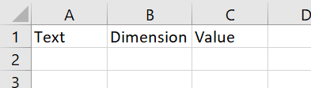Open the worksheet **Trancoding** and type headings **Text**, **Dimension**, and **Value** into the first row as follows:

The **Text** column contains the original value, **Dimension** is ID of the concept being mapped, and **Value** is the destination code from the SDMX DSD.

1. 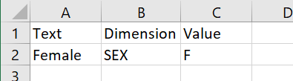Note that the Data worksheet uses **Female** where the date relates to the female sex. The corresponding SDG DSD code for the **SEX** dimension is **F**. Map **Female** to **F** as follows:
2. Complete mappings for remaining **SEX** and **AGE** codes. Note: if you use the SDMX Global Registry to find the codes, remember that the age group you added in Exercise 6 is not in the global DSD, and therefore is not in the Global Registry. You may wish to consult the Exercise 6 manual to find the code, or open Antarctica’s DSD you created in the DSD Constructor.
3. 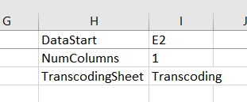Open the Parameters worksheet. Add a reference to the Transcoding worksheet as follows:
4. Open SDMX Converter as described in previous exercises, and convert the spreadsheet to Structure-Specific format using Antarctica’s DSD you created in Exercise 6. Use **Antarctica.xml** as the output file name.  
     
   If any errors are thrown, try to diagnose and resolve the errors.
5. Once you have resolved the errors, click **Download** on the final screen and save the output file.
6. Congratulations! You mapped and converted an Excel spreadsheet using transcoding.