# Exercise 6

# Reference Metadata

The objective of this exercise is to practice how to author SDG metadata.

**Steps**

1. Download the template from <https://github.com/sdmx-sdgs/metadata/raw/master/SDG_Metadata_Template.docm>
2. Rename the file for a particular SDG indicator. The example metadata we will use is for indicator 4.a.1, therefore the file name should look like **SDG_Metadata_4.a.1.docm**
   * Note that in the case of some other indicators, more than one metadata file may be required.
3. Open the file for editing. Press the “Enable editing” and “Enable content” buttons as needed
4. Using the information at the end of this file, complete the template
   * In this case, “Import the SDMX DSD from Global Registry” to use the global SDG DSD to update the dropdowns
   * Select reporting type “National (N)”
   * Select SDG series. Note that multiple series exist for indicator 4.a.1. Use the **Add Series** button to add all series for the indicator.
   * Select Reference area. For this exercise, we will use the reference area “**Antarctica**” (M49 reference area code is 10)
   * Select the metadata language
   * Complete the rest of the template with the metadata provided at the end.
     + For the section related to the “1. Data reporter”, please use your own information.
     + Use some of the features in word to test them, e.g.
       - Bold, italics, underline, lists, headers, tables, pictures, equations (**for the definition and computation method several options were left in the sample metadata so that can be tested**)
       - Colors
5. Save and close the word file
6. In your browser, open <https://sdg-metadata-sdmx.herokuapp.com>
7. Drag in or select your saved Word file, then wait a moment for it to process. Note if there are warnings. If any, correct the issues and convert again.
8. Your browser will automatically download a zip file, containing two versions of the metadata:
   * PDF version: Useful to see how exactly your metadata will be represented in the SDMX
   * SDMX version: This is the completed SDMX output for your metadata.

Examine the files. In the pdf you will be able to see how the rich-text features were parsed/converted.

**Metadata example**

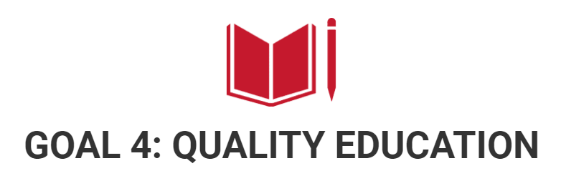

**Goal 4**. Ensure inclusive and equitable quality education and promote lifelong learning opportunities for all

**Target 4.a** Build and upgrade education facilities that are child, disability and gender sensitive and provide safe, non-violent, inclusive and effective learning environments for all

**Indicator 4.a.1** Proportion of schools offering basic services, by type of service (GLOBAL)

**Definition**

Data represents the percentage of schools by level of education (primary education) with access to the given facility or service, such as:

------

(a) electricity; (b) the Internet for pedagogical purposes; (c) computers for pedagogical purposes; (d) adapted infrastructure and materials for students with disabilities; (e) basic drinking water; (f) single-sex basic sanitation facilities; and (g) basic handwashing facilities (as per the WASH indicator definitions).

------

1. electricity
2. the Internet for pedagogical purposes
3. computers for pedagogical purposes
4. adapted infrastructure and materials for students with disabilities
5. basic drinking water
6. single-sex basic sanitation facilities
7. basic handwashing facilities (as per the WASH indicator definitions).

-----

|  |
| --- |
| 1. electricity |
| 1. the Internet for pedagogical purposes |
| 1. computers for pedagogical purposes |
| 1. adapted infrastructure and materials for students with disabilities |
| 1. basic drinking water |
| 1. single-sex basic sanitation facilities |
| 1. basic handwashing facilities (as per the WASH indicator definitions). |

NOTE: The indicator measures the existence in schools of the given service or facility but not its quality or operational state.

**Key Concepts**

a) Electricity: Regularly and readily available sources of power;

b) Internet for pedagogical purposes: Internet that is available for enhancing teaching and learning and is accessible by pupils;

c) Computers for pedagogical use: Use of computers for teaching and learning needs;

d) Adapted infrastructure is defined as any built environment related to education facilities that are accessible to all users, including those with different types of disability. Adapted materials include learning materials and assistive products that enable students and teachers with disabilities to access learning;

e) Basic drinking water is defined as a functional drinking water source accessible to all users;

f) Basic sanitation facilities are defined as functional sanitation facilities separated for males and females on or near the premises;

g) Basic handwashing facilities (according to the WASH Initiative indicator definitions) are defined as functional handwashing facilities, with soap and water.

**Data sources and collection**

Data are provided by Educational organizations or District EO using questionnaires. Data are available by region, district and school. The raw data are checked for quality before being used for further analysis. Logical and arithmetic control of recorded data is carried out.

**Computation Method**

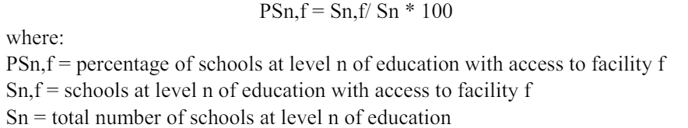

------

PSn,f = Sn,f/ Sn * 100

where: PSn,f = percentage of schools at level n of education with access to facility f

Sn,f = schools at level n of education with access to facility f

Sn = total number of schools at level n of education

-------

$${PS}_{n,f}=\frac{S_{n,f}}{S_{n}}*100$$

Where:

${PS}_{n,f}$ is the percentage of schools at level $n$ of education with access to facility $f$

$S_{n,f}$ schools at level $n$ of education with access to facility $f$

$S_{n}$ total number of schools at level $n$ of education

-------

**For further documentation, please visit:**

Ministry of Education: <https://xxxxxxxxx.com>