# Exercise 3

## Using SDMX Converter to retrieve data from a mapped Excel file

In this exercise, you will use Eurostat SDMX Converter and the Global SDG Data Structure Definition to retrieve data from an Excel file.

1. Open SDMX Converter at <http://dfs-desaiis-56.dpko.un.org:81/converter-webapp>
2. SDMX Converter opens. On the first screen, you select the input file containing the data (**Iraq.xlsx**), the output file where the SDMX data will be written, and the format of the output file.

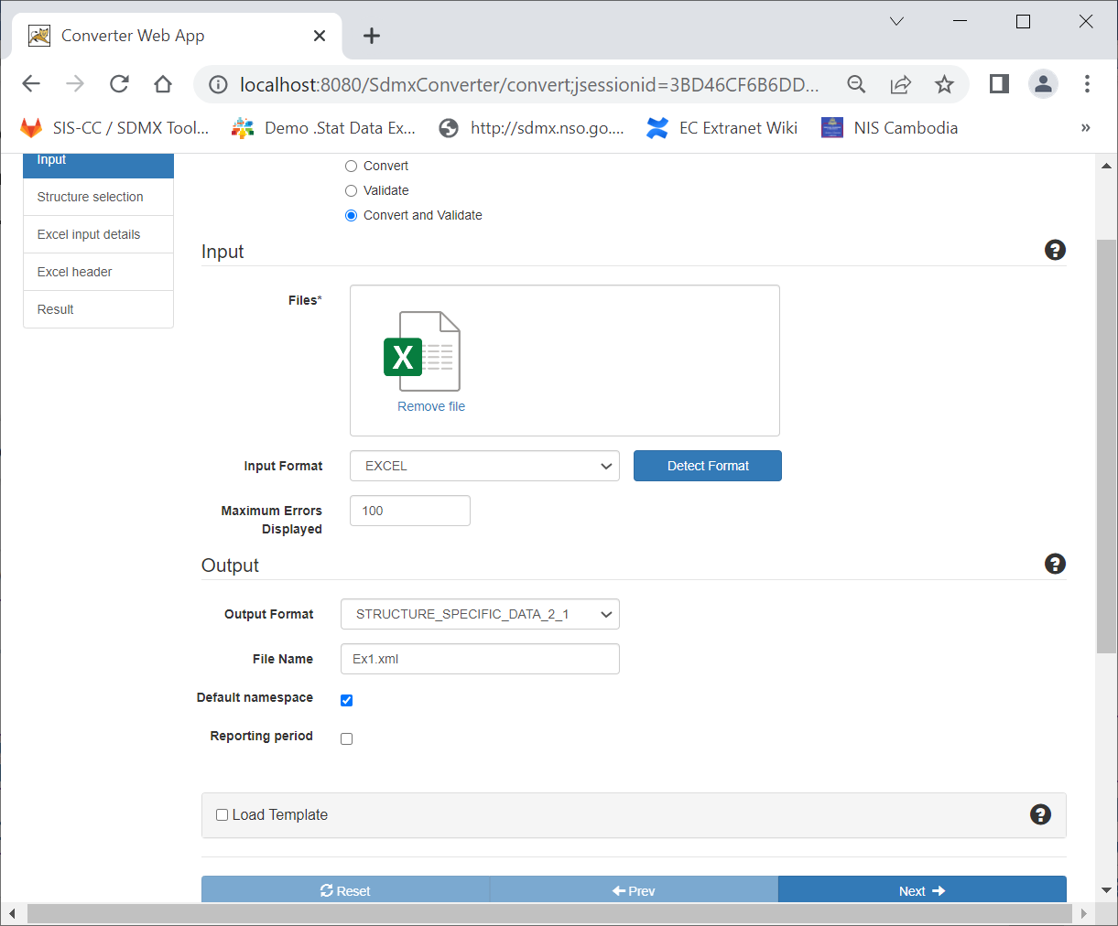

1. Select: **Convert and Validate**

3. Make sure input format is **Excel**

5. Enter output file name, e.g. **Ex1.xml**

2. Drag and drop file **Iraq.xlsx**

6. Click **Next**

4. Select output format: **STRUCTURE_SPECIFIC_DATA_2_1**

1. On this screen, you load the SDG Data Structure Definition from the SDMX Global Registry.

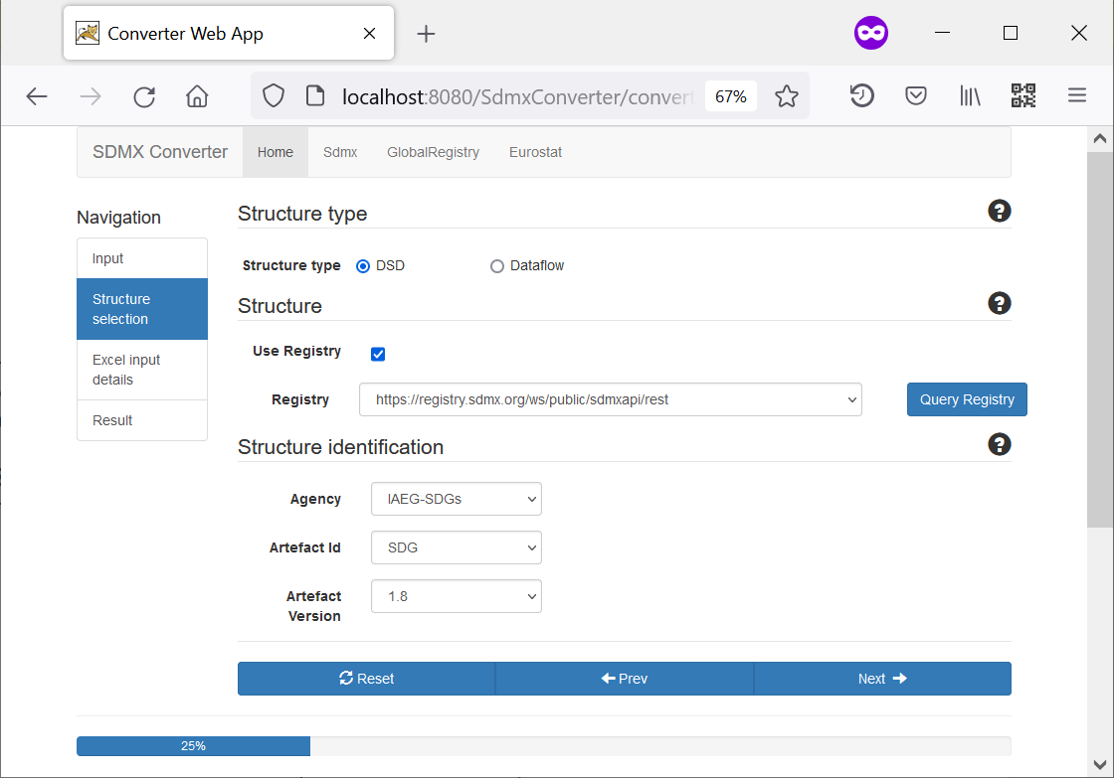

7. Select: **DSD**

9. Select the Global Registry at **https://registry.sdmx.org/...**

8. Check **Registry**

12. Click **Next**

10. Click **Query** **Registry**

11. Select

Agency: **IAEG-SDGs**

Artefact ID: **SDG**

Version: latest version listed

1. On this screen, you can load an SDMX message header and mapping parameters.   
   Every SDMX message must have a header in a defined format, but it is not used in this exercise. As for parameters, they are contained in the Excel file.

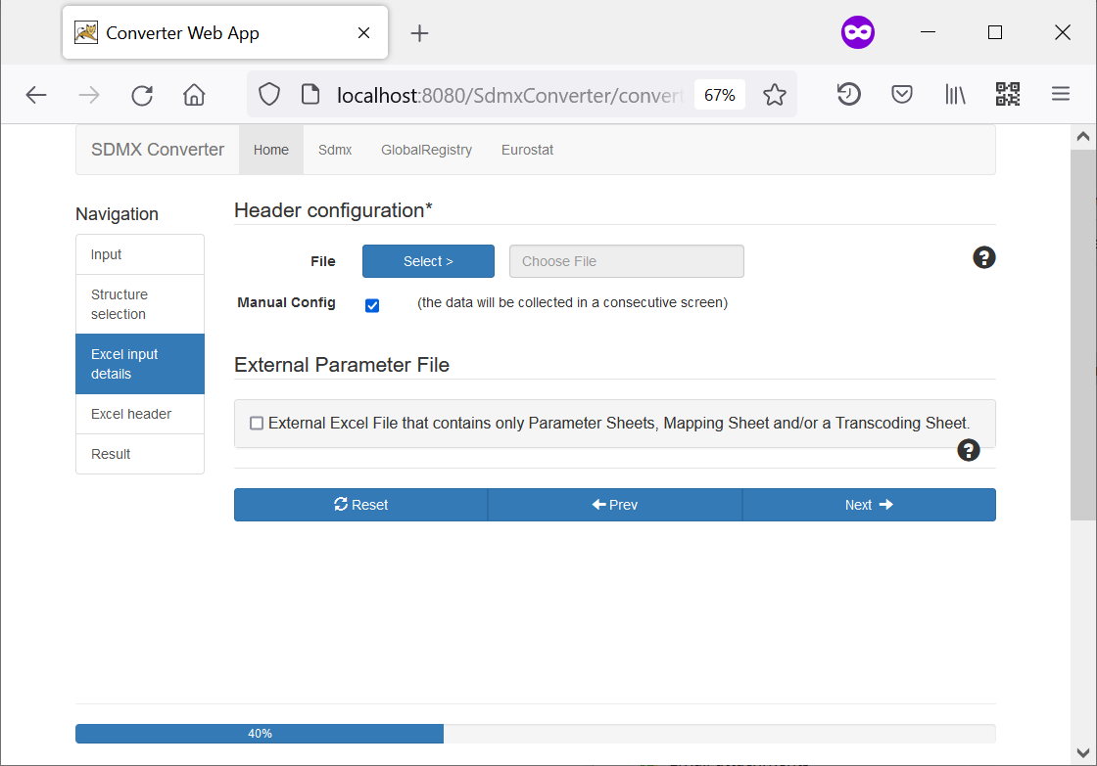

13. Check **Manual Config**

14. Click **Next**

1. On this screen, you can configure the message header. You may wish to update the header fields, or simply leave the defaults because we are not using them.

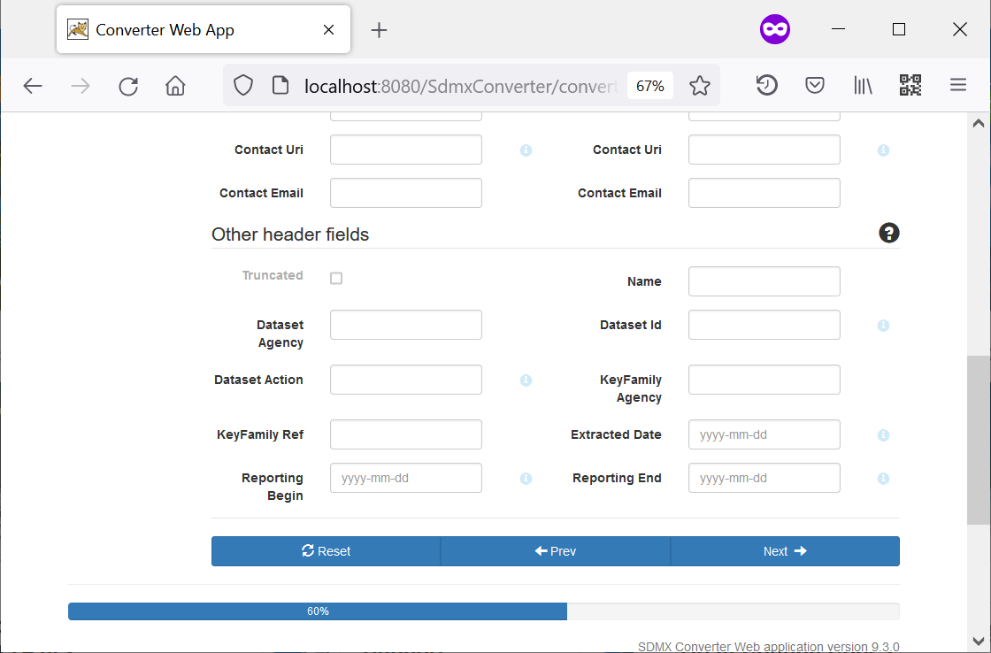

15. Click **Next**

1. If the steps have been completed correctly, data will be retrieved without errors. Click **Download Result**, save the file to your local drive, and open the file with an XML viewer such as Notepad++, or a browser such as Internet Explorer or Firefox.

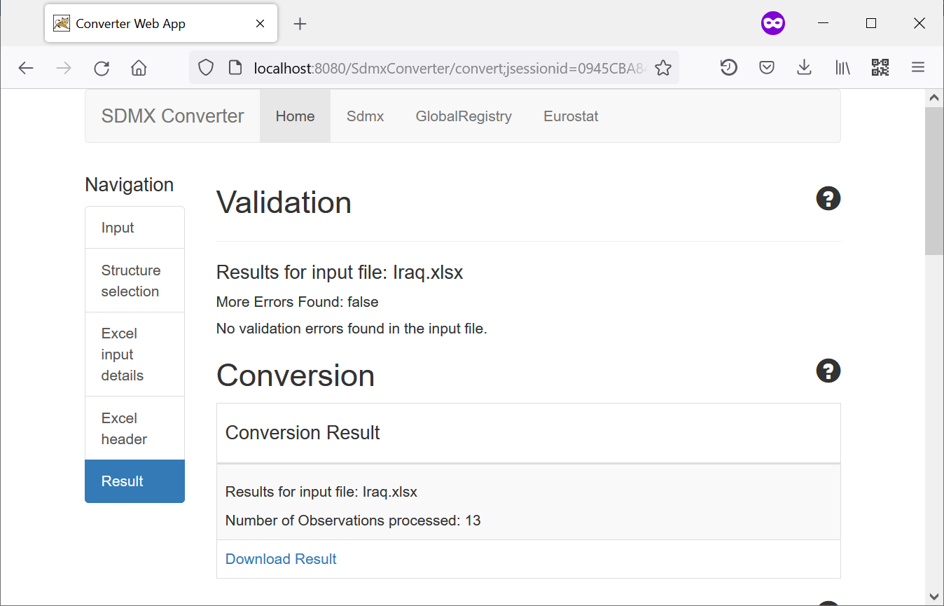

16. Click **Download Result**

1. Congratulations! You have successfully converted a spreadsheet to SDMX using the SDMX Converter and SDG Data Structure Definition.