# Exercise 3

## Creating a national SDG Data Structure Definition

In this exercise, you will create a customized national SDG Data Structure Definition.

1. Open spreadsheet with your national data. Note that it contains the same dataset as Exercise 1, but also includes disaggregation by subnational reference areas[1]. You will need to extend the Reference Area code list with your national data.
2. Create a folder in the Exercise 3 folder and name it **LocalRegistry**.
   * You could also use the AntarcticaRegistry you created previously. However, since the latter contains artificial structures, it is better to create a new local registry. In a real-life situation, you only need one registry and can use it to store multiple DSDs, dataflows, etc.
3. Follow steps 9 through 11 of Exercise 2 to download the Global SDG DSD. Save it in the **LocalRegistry** folder.
4. Follow steps 12 through 15 of Exercise 2 to create a local registry, but name it **LocalRegistry**.
5. Double-click SDG DSD to populate the screen and edit the DSD.

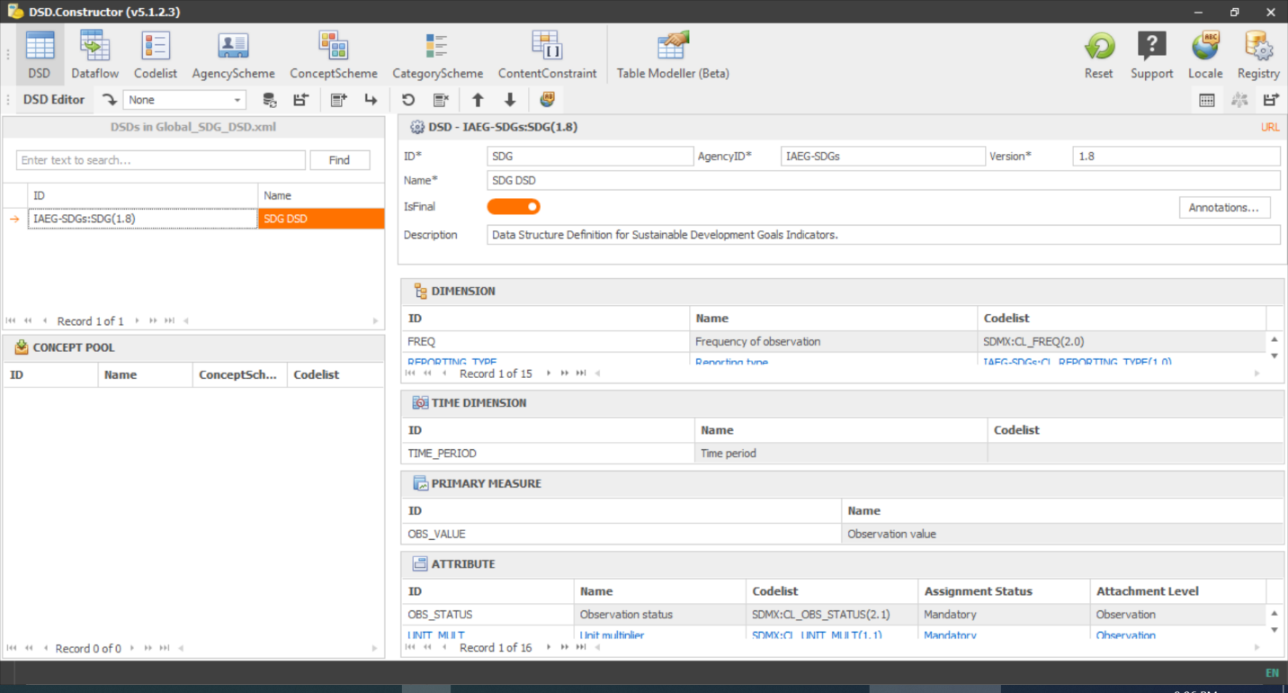

1. 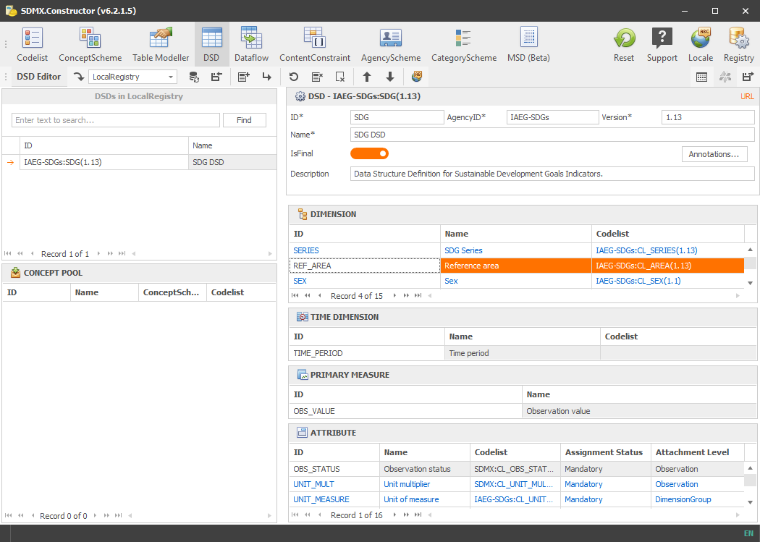In the Dimensions pane, double-click **REF_AREA** to edit the dimension and its code list.
2. The **Edit Dimension** window opens. Before any modification, you must take ownership of affected artefact. In this case, you are updating the code list.
   * Type your NSO’s ID into the **AgencyID**. If your NSO does not yet have an SDMX ID, use the following format: ISO-3166 2-letter code followed by 1. For example, for Libya the agency ID would be **LY1**.
   * Type 1.0 into the **Version** box.
   * Type **<your country>’s reference area code list** into the code list **Name** box.

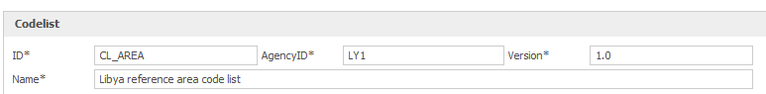

1. Click the + sign below the grid to add a new code.
2. A row is added. Add a row for the first province or governorate code of your country.
   * **ID**: Use the following format: **<YourCountryCode><GovernorateCode>**
   * **Parent**: Use your country code
   * **Name_en** and **Description_en**: add the name in the English language

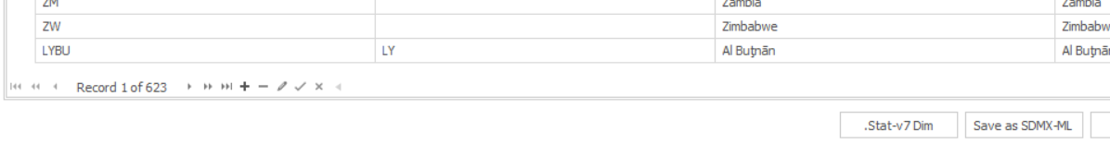

1. Repeat Steps 8 and 9 for all subnational areas in your dataset. Then, click Apply to save the code list and close the window.
2. You return to the DSD Editor window. Note that identity of the code list assigned to the dimension **REF_AREA** has changed.

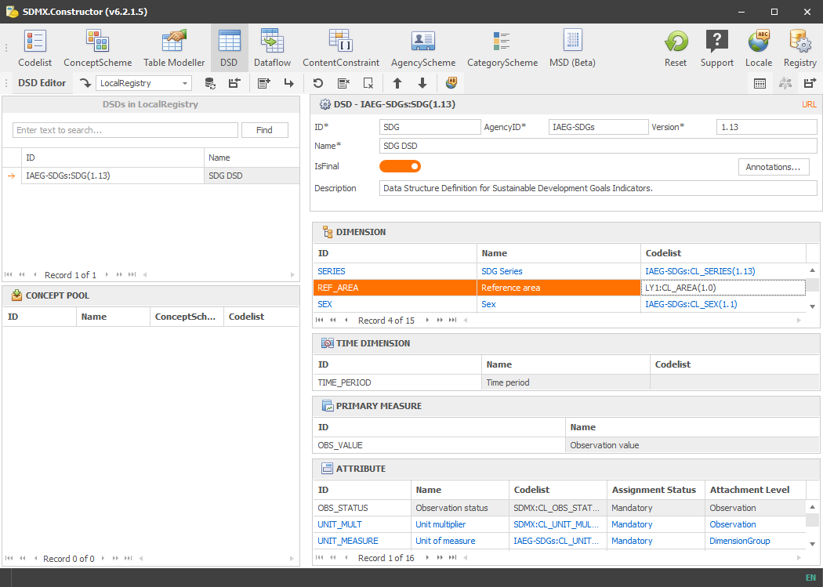

1. Since a code list assigned to a dimension of the SDG DSD has been modified, you also need to take ownership of the DSD itself. Be sure to update the agency ID, version, and DSD name.
   * You may wish to consult Step 23 of Exercise 2. Use your NSO’s SDMX ID and your country’s name instead of Antarctica.
2. 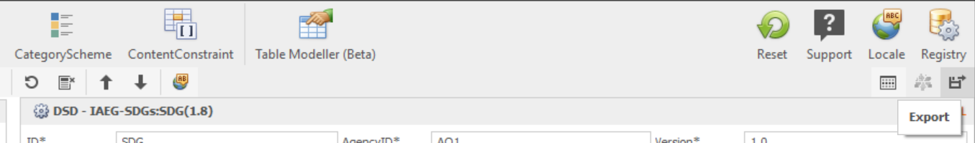Now, you save the DSD into the local registry. Click the **Export** button.
3. The **Export** dialog comes up. Complete the fields as follows:
   * **Use Local ConceptScheme**: **Off** – we did not modify the global concept scheme.
   * **Output Codelists**: **On** – we want the code lists.
   * **Output ConceptSchemes**: **On** – we want the concept scheme.
   * **Export Separate Artefacts**: **Off** – we want the Concept Scheme, Codelists, and DSD in the same file.
   * **Output Name**: leave unchanged
   * **Output folder**: paste the address of the folder **LocalRegistry**.
4. Click Run. You will see a warning that all files will be merged into a single file named **LocalRegistry**. Click **Yes** to continue.
5. Now, you will create a dataflow. Click the **Dataflow** button in the ribbon.
6. Complete the dataflow fields as follows:
   * **ID: DF_SDG_<YourCountryCode>**
   * **AgencyID: <YourAgencyID>**
   * **Version: 1.0**
   * **Name: <YourCountry> National SDG Indicators**
   * **IsFinal: True**
   * **Description: <YourCountry> National SDG Dataflow**
   * 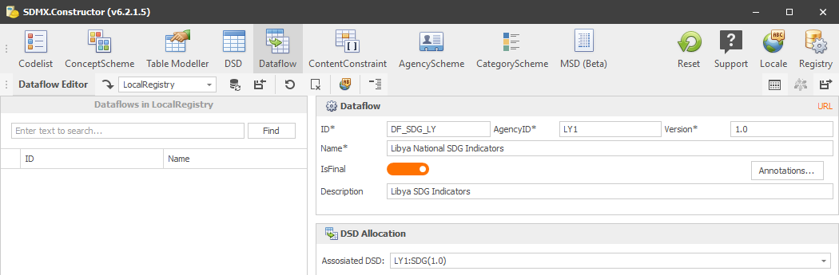**Associated DSD: <YourAgencyID>:SDG(1.0)**
7. Click **Export** and save the dataflow to the **LocalRegistry** folder. A warning will again come up that the files will be merged. Click **Yes** to proceed.
8. If you have time, you may wish to open the file **LocalRegistry.xml** in a browser (Chrome, Firefox, Edge) and inspect its contents.
9. Congratulations! You have downloaded and customized the global SDG DSD with your subnational reference areas, and created a national dataflow.

1. In the case where subnational disaggregation is not available, another dimension includes nation-specific codes that need to be added to the global code list.