# Exercise 2

## Creating a customized SDG Data Structure Definition

In this exercise, you will customize the SDG Data Structure Definition using the ILO DSD Constructor.

1. Open spreadsheet **Exercise 2.xlsx**. Note that it contains Antarctica’s SDG Indicator 1.2.1 “Proportion of population living below the national poverty line, by sex and age”, and is disaggregated by sex and age.
2. Create a folder in the Exercise 2 folder and name it **AntarcticaRegistry**.
3. Start your browser and open page <https://registry.sdmx.org>. This is the SDMX Global Registry, where global and cross-domain DSDs, concepts, code lists, and other artefacts are stored. Click **SDMX Global** **Registry Home**.
4. Click **Data** on the left. In the menu that opens, click **Data Structures**. This will list DSDs stored at the Global Registry.

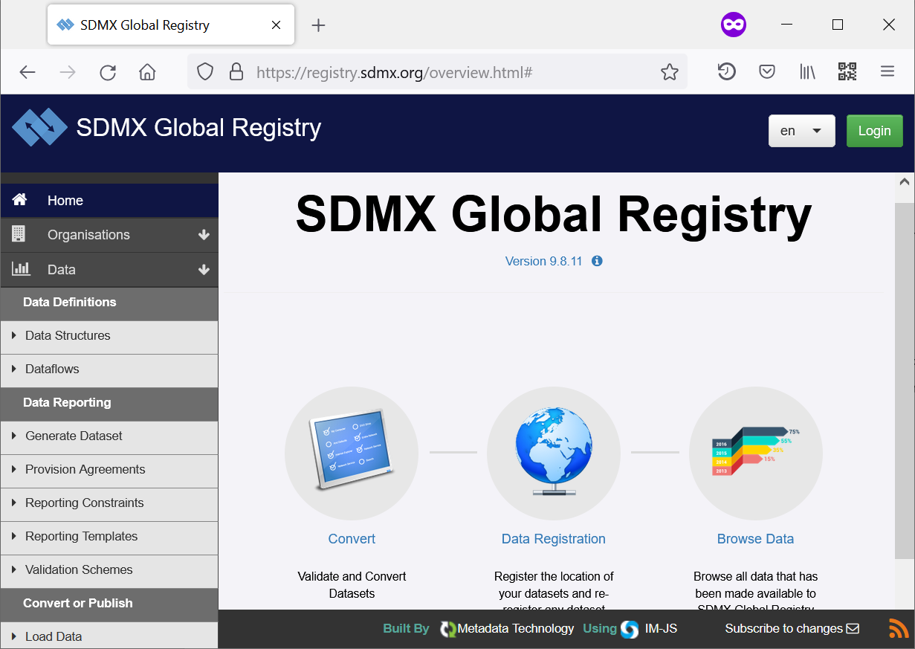

1. Global DSDs are now displayed. To quickly locate the SDG DSD, select **IAEG-SDGs** in the agency drop-down. Then, select the **SDG DSD** and click **View Data Structure Definition**.

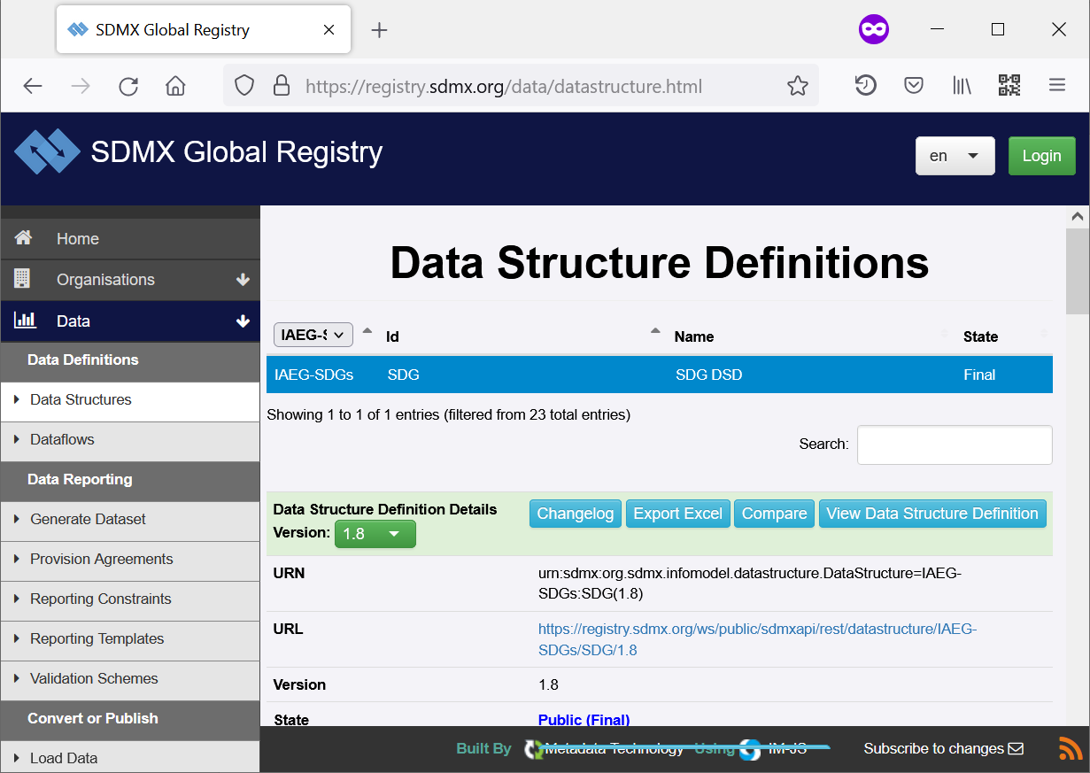

1. The SDG Data Structure Definition opens and its concepts and their representations are displayed. Select the **SERIES** dimension on the left. The **CL_SERIES** code list is displayed. Type **1.2.1** into the search box to quickly find series codes for the indicator.

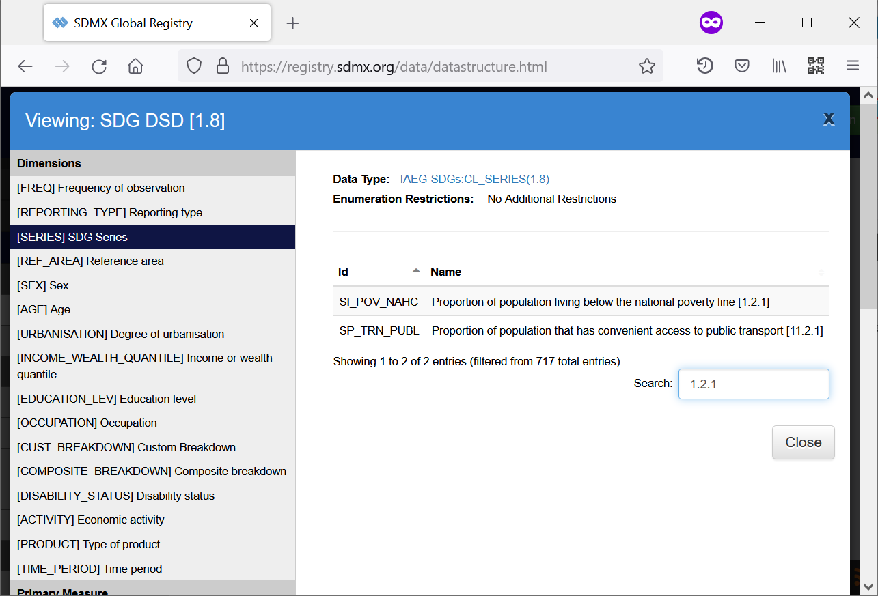

1. 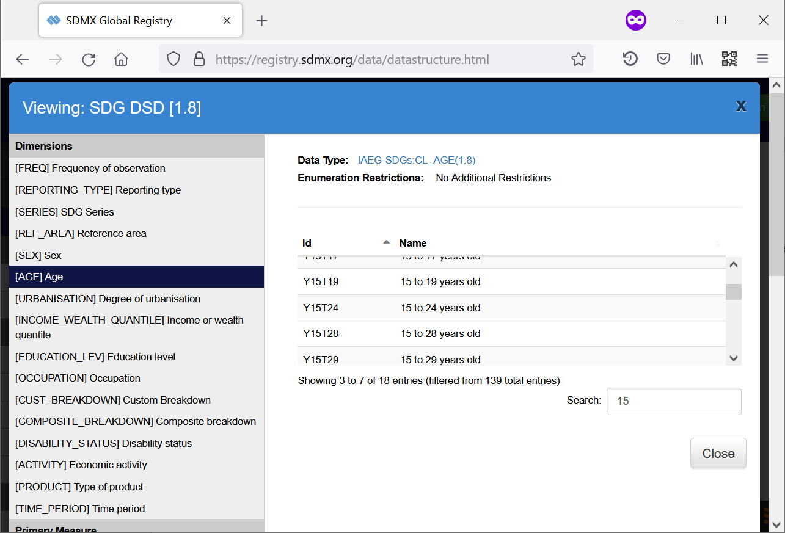Click the **AGE** dimension on the left and check whether all age groups used in the dataset are present in the code list.
2. You may notice that one of the age groups is missing from the global DSD. To add the age group to Antarctica’s national DSD, you will need to download the DSD, take ownership of affected artefacts, and add the age group to the code list.
3. Click **Close** to close the DSD window. In the menu on the left, select **Web Service** and then **Structure**. The **REST Web Service** window opens.

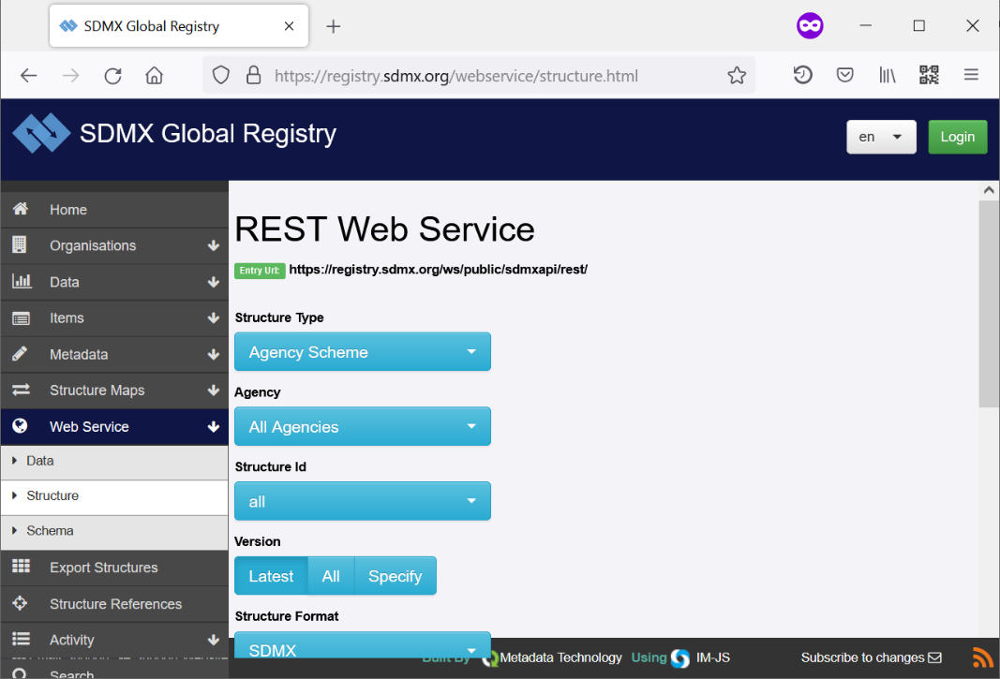

1. On this screen, you can select and download one artefact or a group of related artefacts. Make selection as follows:
   * Structure Type: **Data Structure**
   * Agency: **IAEG-SDGs**
   * Structure Id: **SDG**
   * Version: **Latest**
   * Structure Format: **SDMX**
   * Sub-format: **SDMX-ML 2.1**
   * Pretty print XML: **Yes**
     + Optional; helps viewing and speeds up processing
   * Detail: **Full**
   * References: **Children**
     + 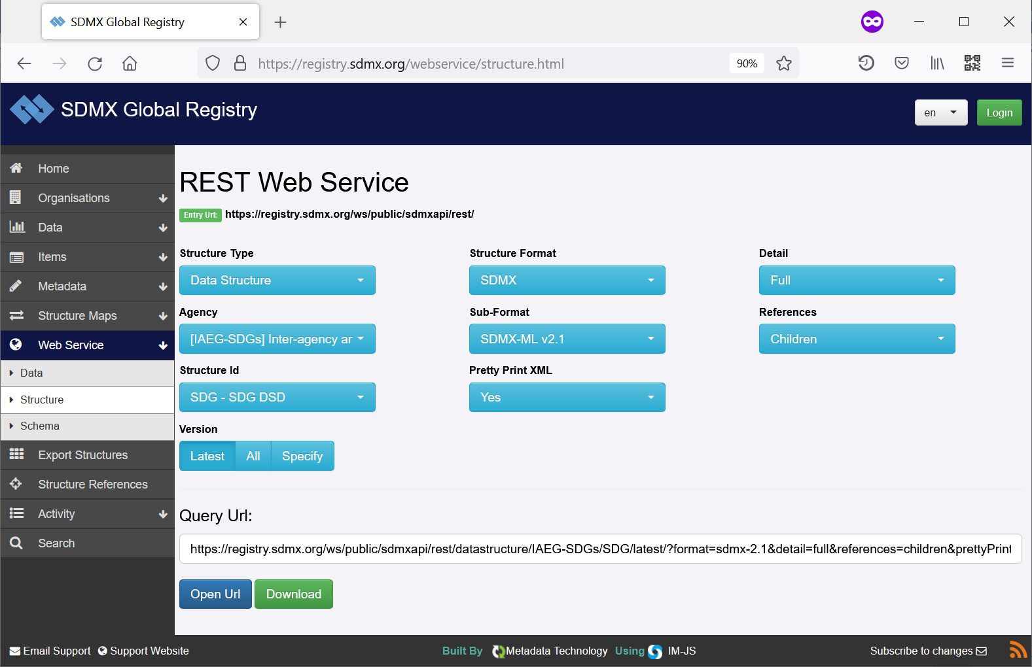This will download the DSD and all artefacts that it references, i.e. Agency Scheme, Concept Scheme, and Code Lists. If **All** is selected then all Dataflows and Content Constraints will also be downloaded.
2. Click **Download** and save the file into the folder **AntarcticaRegistry** that you created at Step 2.
   * You may also wish to click **Open URL** and inspect the structure. It should contain the Agency Scheme, Concept Scheme, Code Lists, and Data Structure (DSD).
3. 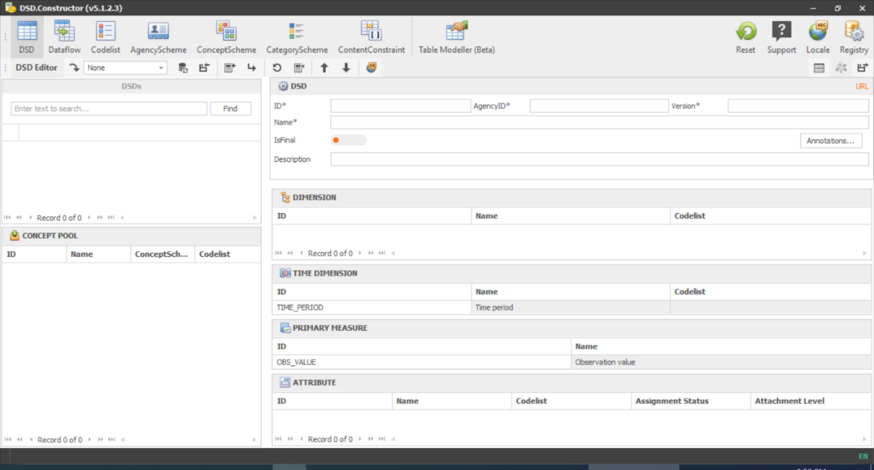Now that you have downloaded the global SDG DSD, you will customize it. Start the ILO DSD Constructor. It opens in the DSD Editor mode.
4. Click the **Registry** button in the top-right corner of the Window. The **Add/Edit SDMX Registry** dialogue opens up. This allows you to configure an SDMX Registry in a local folder.
5. 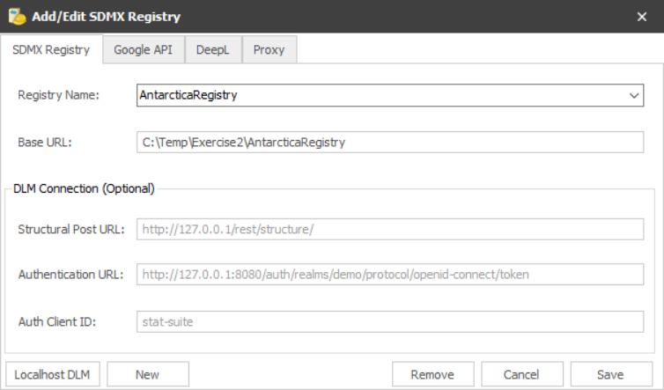Type **AntarcticaRegistry** into the **Registry Name** field, and paste the path to the folder AntarcticaRegistry you created into the **Base URL** field. Then click **Save**.
6. 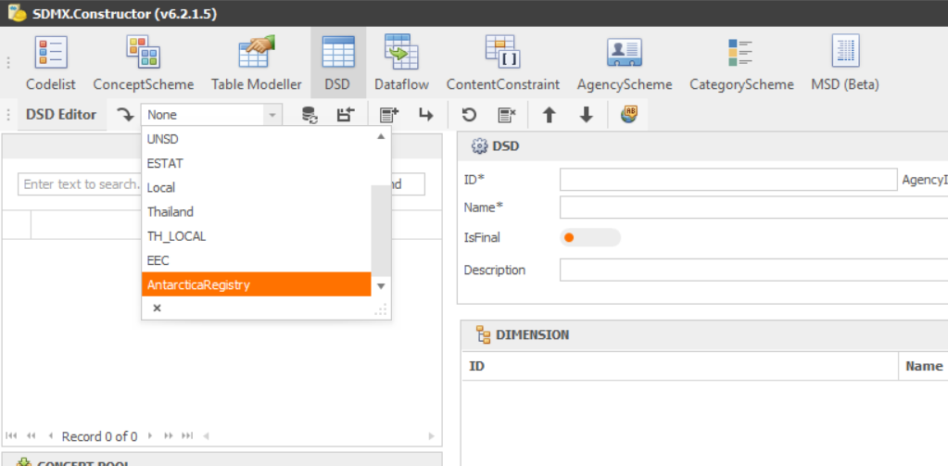In the Registry dropdown in the top-left corner of the screen, choose **AntarcticaRegistry**.
7. Double-click SDG DSD to populate the screen and edit the DSD.

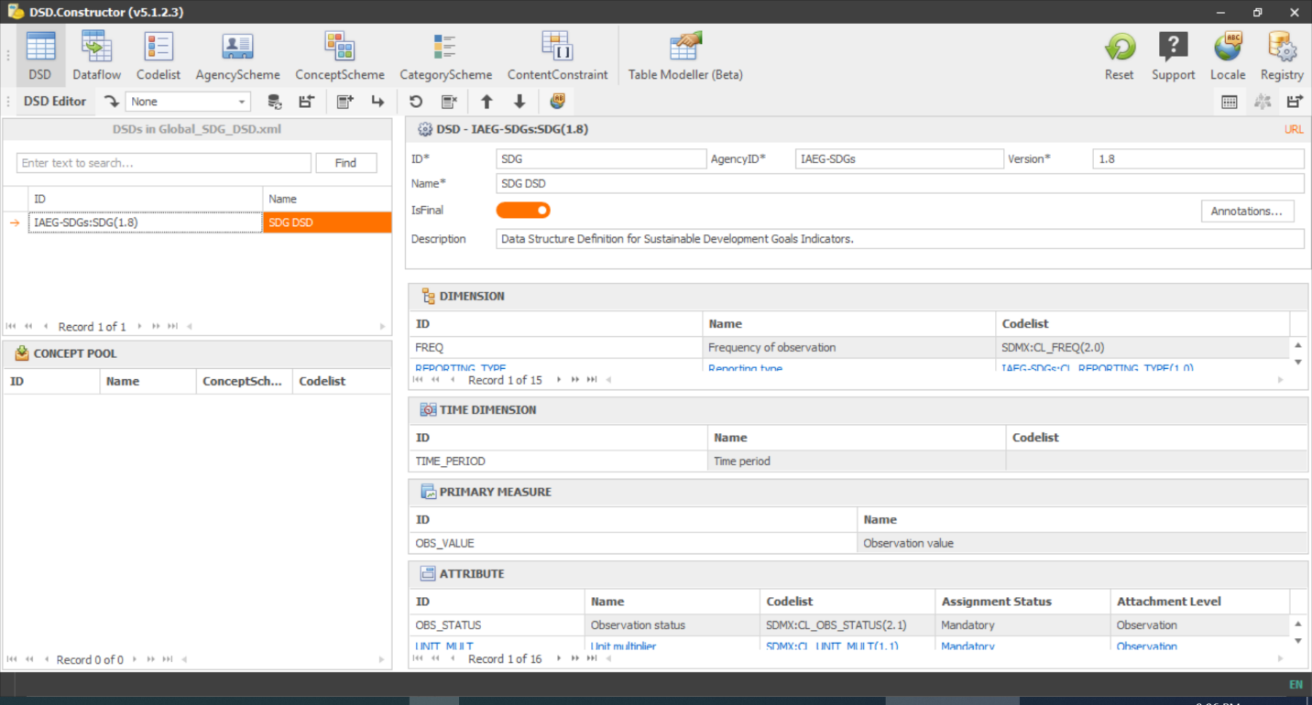

1. In the Dimensions pane, double-click AGE to edit the dimension and its code list.

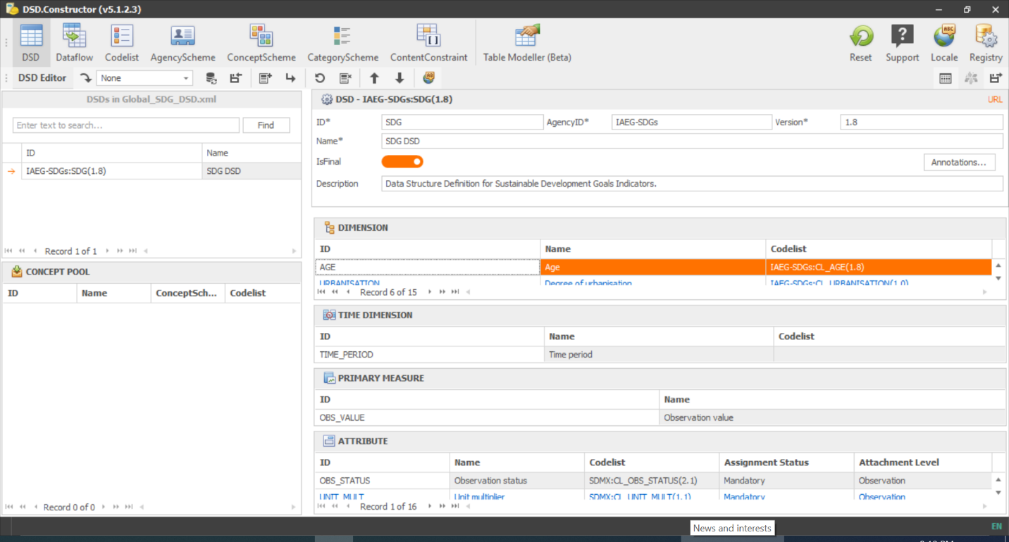

1. 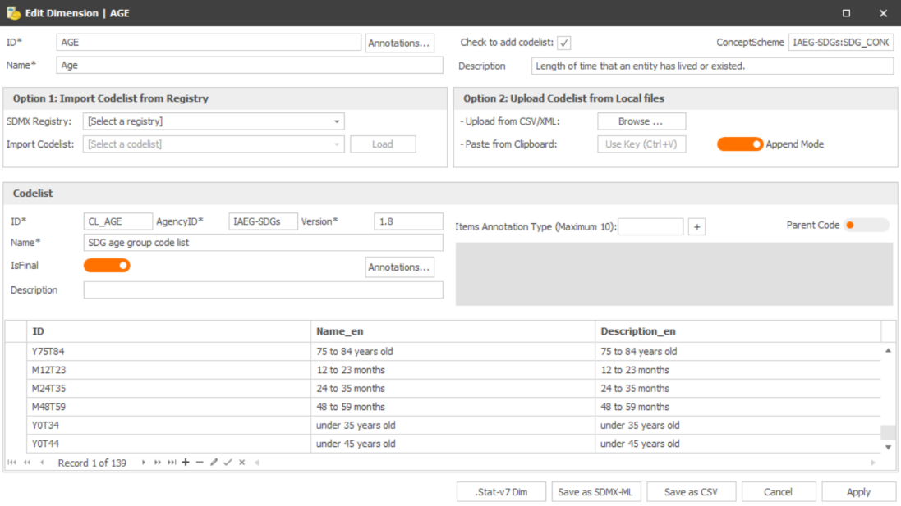The **Edit Dimension** window opens. Observe that the concept ID, name, and other properties, as well as code list ID, name, and other properties, are displayed.
2. Before any modification, you must take ownership of affected artefact. In this case, you are updating the code list.
   * Type **AQ1** into the **AgencyID** box to assign ownership to agency AQ1.
   * Type 1.0 into the **Version** box.
   * Type **Antarctica SDG age group code list** into the code list **Name** box.

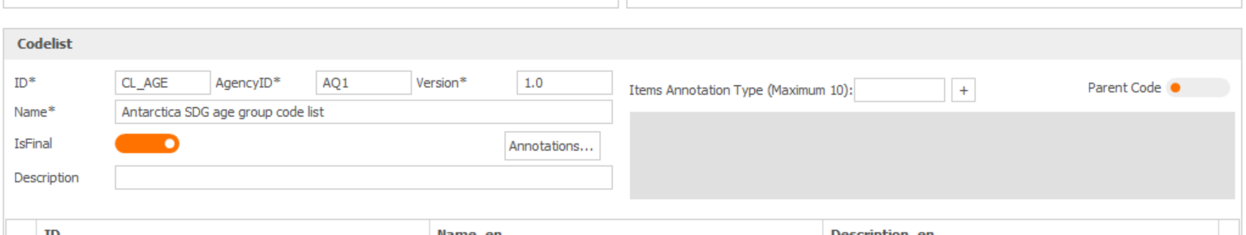

Note 1: Since this is Antarctica’s first age group code list, it’s a good idea to change the version to 1.0. Later, if the code list needs to be modified after the DSD is published, the code list version must change. See [Guidelines on the Versioning of SDMX Artefacts](https://sdmx.org/wp-content/uploads/Guidelines_on_versioning_v1_0.pdf) for further detail.

Note 2: Normally, while a code list is under development, the **IsFinal** property should be set to False. However, since in this case we are immediately releasing the DSD, we can leave this property at True.

1. 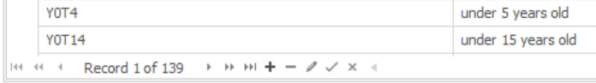Click the + sign below the grid to add a new code.
2. A row is added. Type in the code as follows:
   * ID: **Y25T59**
   * Name_en and Description_en: **25 to 59 years old**

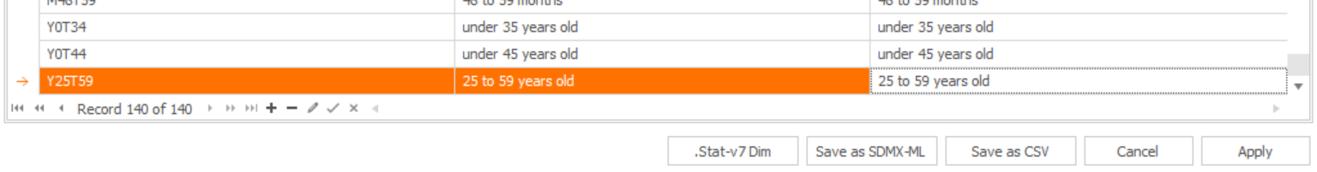Then, click **Apply** to save the code list and close the window.

1. You return to the DSD Editor window. Note that identity of the code list assigned to the dimension **AGE** has changed.

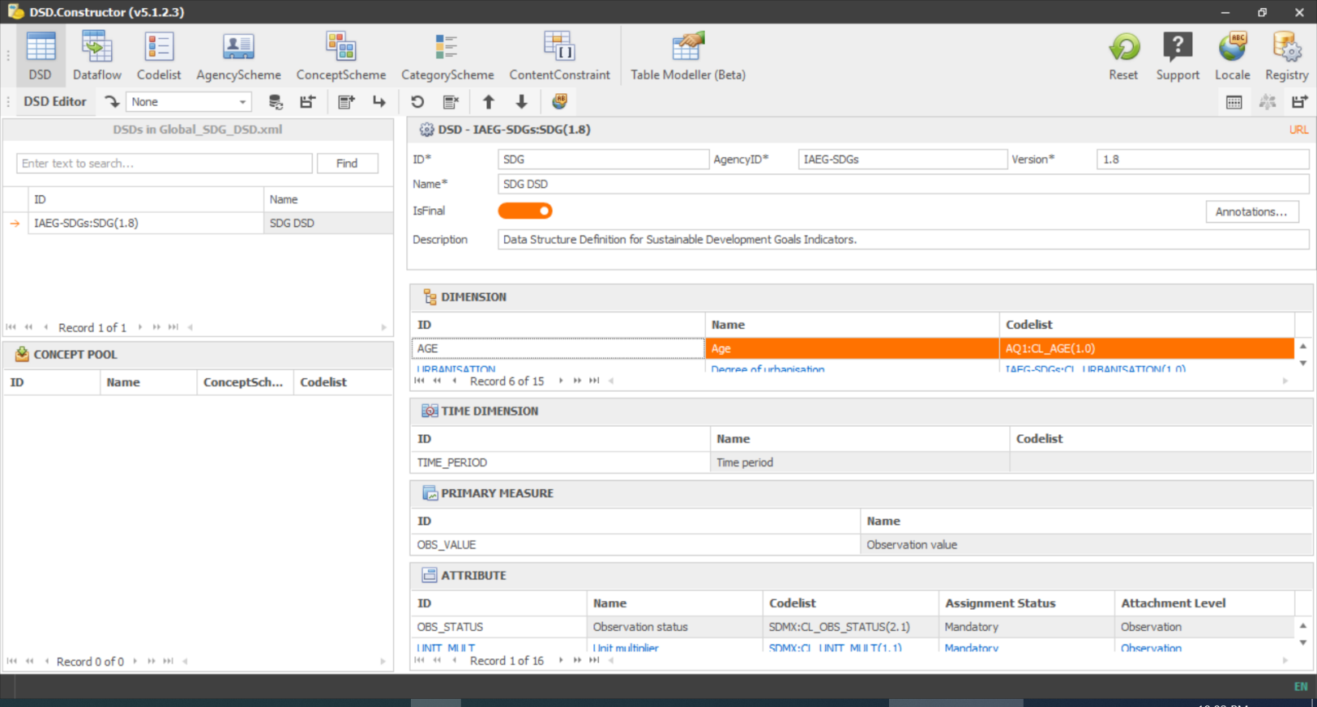

1. Since a code list assigned to a dimension of the SDG DSD has been modified, you also need to take ownership of the DSD itself. Update the DSD properties as follows:
   * AgencyID: **AQ1**
   * Version: **1.0**
   * Name: **Antarctica SDG DSD**
   * Description: **Antarctica’s National Data Structure Definition for Sustainable Development Goals Indicators**.

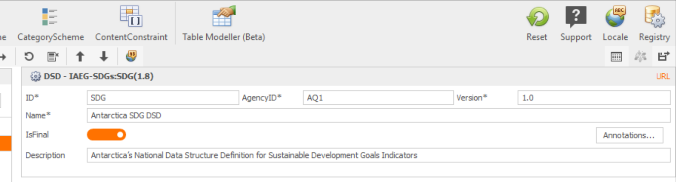

1. 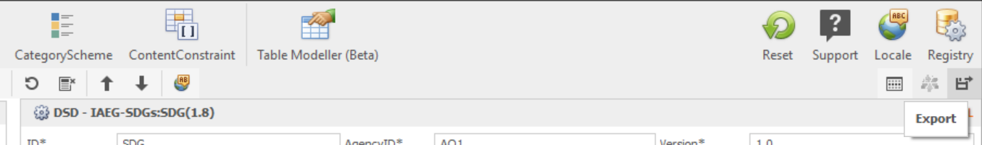Now, you save the DSD into the local registry. Click the **Export** button.
2. The **Export** dialog comes up. Complete the fields as follows:
   * **Use Local ConceptScheme**: **Off** – we did not modify the global concept scheme.
   * **Output Codelists**: **On** – we want the code lists.
   * **Output ConceptSchemes**: **On** – we want the concept scheme.
   * **Export Separate Artefacts**: **Off** – want the Concept Scheme, Codelists, and DSD in the same file.
   * **Output Name**: **AQ_SDG_1_0** (leave unchanged)
   * **Output folder**: paste the address of the folder **AntarcticaRegistry**.

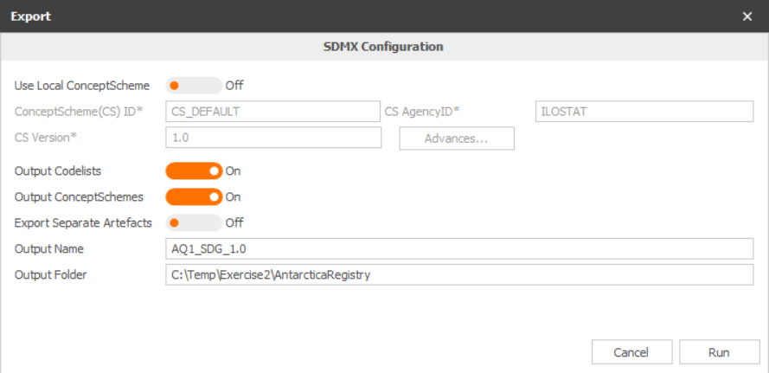

1. Click Run. You will see a warning that all files will be merged into a single file named **LocalRegistry**. Click **Yes** to continue.
2. Now, you will create a dataflow. Click the **Dataflow** button in the ribbon.

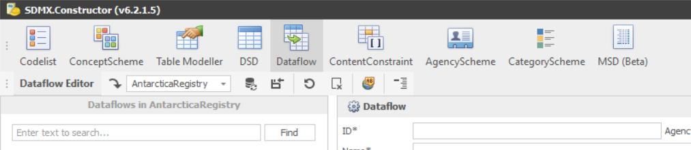

1. Congratulations! You have customized and saved a national SDG DSD.
2. Complete the dataflow fields as follows:
   * **ID: DF_SDG_AQ**
   * **AgencyID: AQ1**
   * **Version: 1.0**
   * **Name: Antarctica National SDG Indicators**
   * **Description: Antarctica National SDG Dataflow**
   * **Associated DSD: AQ1:SDG(1.0)** (Antarctica SDG DSD)

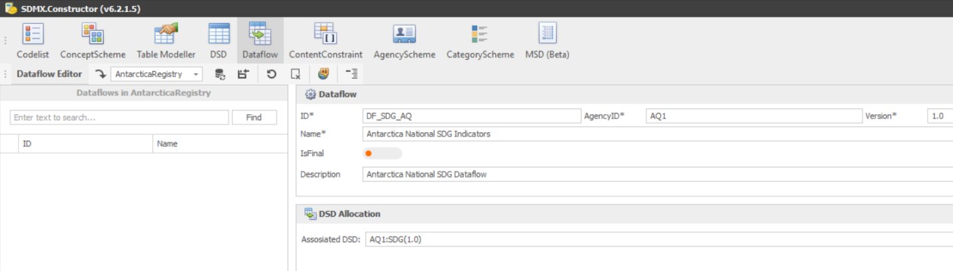

1. Click **Export** and save the dataflow to the **AntarcticaRegistry** folder. A warning will again come up that the files will be merged. Click **Yes** to proceed.
2. If you have time, you may wish to open the file **LocalRegistry.xml** in a browser (Chrome, Firefox, Edge) and inspect its contents.
3. Congratulations! You have downloaded and customized the global SDG DSD, and created a national dataflow.