**#1**

Lebanon central bank governor faces corruption charges

<https://www.bbc.com/news/world-middle-east-64746658>

* Published 23 February

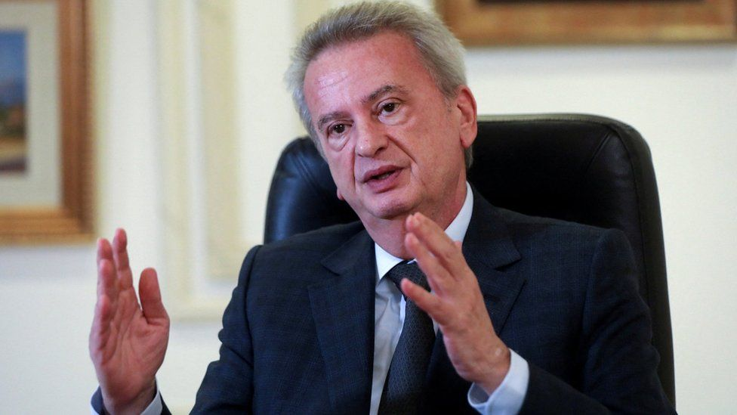IMAGE SOURCE,REUTERS

Image caption,

Riad Salameh, who has led the Banque du Liban for 30 years, denies any wrongdoing

**By David Gritten**

BBC News

**Lebanon's central bank governor Riad Salameh has been charged with money laundering, embezzlement and illicit enrichment, the state news agency says.**

Public prosecutor Judge Raja Hamoush has also filed charges against Mr Salameh's brother Raja and an adviser, according to the National News Agency.

The brothers deny any wrongdoing.

The judge's move follows an 18-month investigation into allegations that they embezzled $300m (£249m) from the Banque du Liban between 2002 and 2015.

Riad Salameh - who has led the bank for 30 years - has faced intense scrutiny over his role in Lebanon's economic collapse since 2019.

The country is experiencing one of the most severe and prolonged depressions the world has seen, with its currency losing more than 90% of its value against the dollar and the annual inflation rate soaring to 170% last year.

That has left more than 80% of the population living in poverty and struggling to afford food and medicine.

Before the crisis, Mr Salameh was widely praised for having kept the Lebanese pound stable and the banking system afloat despite years of political turmoil.

[**The National News Agency reported on Thursday that Judge Hamoush had charged Riad Salameh, Raja Salameh and his assistant Marianne Howayek**](https://www.nna-leb.gov.lb/en/justice-law/596869/judge-hamoush-charges-salameh-his-brother-and-his) with embezzling public funds, forgery, illicit enrichment, money laundering, and violation of tax law.

It provided no further details, but said the judge had referred the case file to Beirut First Investigative Judge Charbel Bou Samra, "demanding that they be interrogated and that the necessary judicial warrants be issued against them".

Riad Salameh told Reuters news agency in a text message that the charges were "not an indictment" and promised to co-operate with the judicial process.

"I am respectful of the laws and of the judicial system and will abide by the procedure, and as you know one is innocent till proven guilty by a court of law," he wrote.

He has previously dismissed the accusations as part of an effort to make him a scapegoat for Lebanon's economic collapse.

His critics have questioned how he amassed a substantial personal fortune.

He has insisted that the source was the $23m he earned as an investment banker before becoming the governor of Banque du Liban in 1993. He has said that he "wisely invested" that money and that his wealth has grown over time.

Authorities in Switzerland, France, Germany, Luxembourg and Liechtenstein are also investigating Mr Salameh and his brother over similar allegations.

A judicial delegation from three of those European countries travelled to Beirut last month to interview bankers and other witnesses. They are due to return in early March to continue their investigation.

**#2**

**Counterfeit medicine endangering Somali lives**

[**https://www.aljazeera.com/features/2015/7/3/counterfeit-medicine-endangering-somali-lives**](https://www.aljazeera.com/features/2015/7/3/counterfeit-medicine-endangering-somali-lives)

*New government measures are taken to mitigate counterfeit trade in expired and toxic medicines.*

By [**Hamza Mohamed**](https://www.aljazeera.com/author/hamza_mohamed_20131279255889469) **-** Published On 3 Jul 20153 Jul 2015

**Mogadishu, Somalia –**Unlicensed clinics and pharmacies with unqualified staff have been dispencing counterfeit and expired medicines that are making people sick and endangering the lives of S omalis.

The sick can be seen walking towards the hospital at dawn, before any other souls venture out onto the streets of Mogadishu. They move slowly, placing one shaky limb before the other, accompanied by the cool ocean breeze and the sound of crowing roosters.

Those with a dollar to spare take a tuk-tuk. They are all heading to a high-walled guarded compound in the relatively well-off neighbourhood in Mogadishu’s Hodan district.

These latest victims of Mogadishu’s thriving counterfeit and expired medication industry hope to get treatment at one of the few licensed hospitals in the city.

They are also the lucky ones. Many people who are sickened by the dubious medication do not make it this far.

**Damaged organs**

Every morning more than 50 patients gather at Doctor Osman Mohamud Dufle’s specialist hospital. Several among them are usually people who have suffered complications caused by the expired or counterfeit medication prescribed to them by unqualified health workers.

Osman Mohamud Muhumed was one of them and had come to this private hospital to seek treatment. The 52-year-old had sought treatment for what appeared to be malaria, but ended up bedridden for six months after taking medication given to him by doctors at a clinic near his home just outside the city.

He could barely stand without assistance. Saggy skin with hardly any flesh shrouded his body, his breathing heavy and laboured as he recounted his story.

“I went to a clinic near my home. They gave me what they said was medicine,” he told Al Jazeera.

“At first the medicines did not work and then as I continued taking them as they advised me, it made my situation worse. They kept on telling me to continue taking them. It got so bad; the drugs almost killed me,” Muhumed said, his skeletal body looking lost on the hospital stretcher.

No one really knows how many patients fall victim to expired or counterfeit medication in Somalia. In this seaside city of more than a million people, there is a clinic or pharmacy on almost every street corner. Most are unregistered and employ unqualified staff. Colourful murals on their walls and offers of cheap medicine help maintain a steady stream of customers.

Muhumed’s liver now barely functions – his body had to be cleansed of the toxic concoction he had ingested; his kidneys are not in much better shape.

**Numbing the senses**

Not far from the hospital where Muhumed was being treated, Nuurto Hassan Mursal sat with her palms on her cheeks and her legs crossed.

Mursal, a mother of 10, was handicapped by taking what she thought was medication to treat her severe migraine. She looked visibly sick as she sat in her crumbling two-bedroom house made of brick walls and a tin roof.

The medication had killed off all sensation in her feet and had covered her body with round white blisters that later turned to patches the size of golf balls. But she was too traumatised to make another trip to any of the city’s hospitals.

“I can’t feel anything. I wouldn’t know if I walked on fire,” Mursal said. “It is like my feet are not part of my body,” she said pinching her feet to emphasise her point.

After her experience, hospitals and pharmacies are the last place she visits if she feels unwell. She prefers prayer to medication in seeking relief from an illness.

“I don’t want to risk it again. My children, when they are sick I don’t take them to hospitals either. The medicines they give you can kill you instead of healing you. I know better,” said Mursal.

**‘Silent killers’**

Doctors feel powerless as traders flood the market with not just counterfeit and expired medicines, but also sub-standard ones. Doctor Dufle’s hospital, one of the biggest private clinics in the city, has seen firsthand what these drugs do to patients.

Every month more than 30 patients who have been given expired or counterfeit medicine, walk through the doors of his hospital. “Expired and fake drugs have killed more than bombs and rockets. These drugs are silent killers,” Dufle said as he attended to a patient suspected of taking toxic drugs.

“They are worse than bombs because a bomb kills 10 or 20 people. But these drugs can kill hundreds of people and no one will hear about it,” Dufle told Al Jazeera.

Somalia’s health sector was decimated after the collapse of the central government in 1991. Until recently, the country’s ports were controlled by individuals who made it easy to import medicine through a simple monetary exchange.

**Government action**

But the government, which has been preoccupied with tackling security issues and taking back the territories controlled by [al-Shabab](http://www.aljazeera.com/news/2015/06/al-shabab-fighters-kill-police-officers-somalia-150620083855391.html)fighters, is finally starting to turn its attention to this deadly trade.

Among the government’s efforts is a warehouse which has been built complete with air conditioning and cooling systems to store all drugs donated to the government by international organisations and other countries. Government inspectors check the medicines before distributing them to the hospitals in the city.

Doctor Abdirizak Yussuf, the director of the health ministry, inspects new shipments of donated medicines at the warehouse, which is located a short drive from the Mogadishu port. “We have recently made it compulsory for all those importing medicines and who sell it to patients to register,” Yussuf told Al Jazeera.

“We also have before the parliament a drug policy bill which, when passed, will solve all these issues,” Yussuf said confidently.

The government’s efforts to curb the lucrative but deadly trade have been welcomed by doctors and health workers. “It is about time someone did something about this awful trade,” Dufle said.

“The government should punish severely anyone caught with expired medicines with the intention of selling it to anyone. These drugs will continue to kill people if these people are not punished,” he added.

For Mursal, the government’s intervention has come too late. “No, no, no. I will not advise anyone to take a chance and go to any hospital in this city. They will give you poison.”

**#3**

**UAE drug bust: 2.25mn Captagon tablets seized by Abu Dhabi Police**

<https://www.arabianbusiness.com/culture-society/uae-drug-bust-2-25mn-captagon-tablets-seized-by-abu-dhabi-police#:~:text=The%20Abu%20Dhabi%20Police%20has,country%20in%20the%20Middle%20East>

Smugglers planned to sell the illicit drugs in the UAE and ship the rest to a neighbouring country in the Middle East

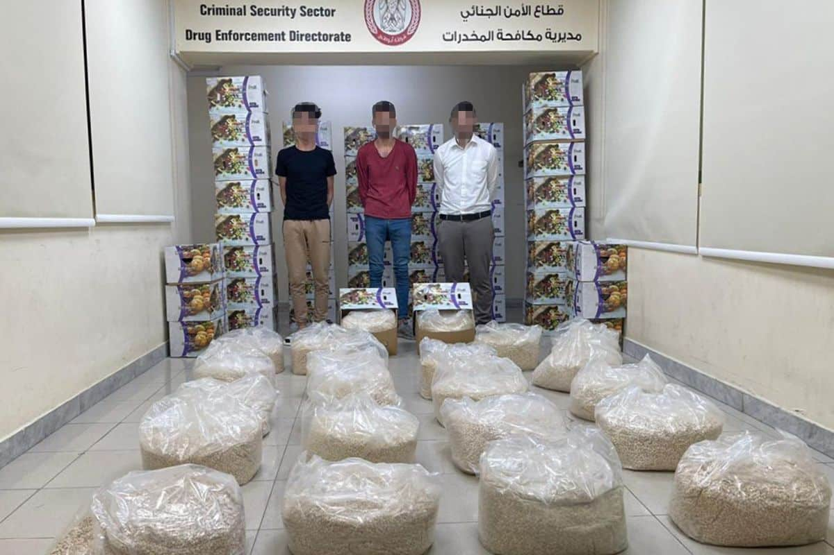Image: Abu Dhabi Police

The Abu Dhabi Police has arrested three men after 2.25 million [Captagon pills](https://www.arabianbusiness.com/culture-society/uae-drug-bust-abu-dhabi-police-arrest-man-with-4-5-million-captagon-pills" \t "_blank) were found in boxes labelled as dried apricots.

The authority said that the smugglers planned to sell the illicit drugs in the UAE and ship the rest to a neighbouring country in the Middle East.

“One million of these tablets were destined for the domestic market, while the remaining tablets were meant for smuggling,” Brigadier General Taher Al Dhaheri, director of Abu Dhabi Police’s anti-narcotics team said.

Al Dhaheri also said the operation was successful due to partnership and co-operation with authorities in the UAE.

He said the operation was successful thanks to a comprehensive plan and co-operation with authorities in the UAE.

**UAE authorities alerted of smuggling plan**

The three men were being tracked by officers after being alerted of their plan to smuggle the drugs.

[#أخبارنا](https://twitter.com/hashtag/%D8%A3%D8%AE%D8%A8%D8%A7%D8%B1%D9%86%D8%A7?src=hash&ref_src=twsrc%5Etfw) | [#شرطة\_أبوظبي](https://twitter.com/hashtag/%D8%B4%D8%B1%D8%B7%D8%A9_%D8%A3%D8%A8%D9%88%D8%B8%D8%A8%D9%8A?src=hash&ref_src=twsrc%5Etfw) تضبط 2.25 مليون حبة "كبتاجون" في صناديق فواكه  
  
التفاصيل:<https://t.co/JWS03T7Gqt> [pic.twitter.com/bD0KxpOqgW](https://t.co/bD0KxpOqgW)

— شرطة أبوظبي (@ADPoliceHQ) [May 8, 2023](https://twitter.com/ADPoliceHQ/status/1655438316018204674?ref_src=twsrc%5Etfw)

The drugs were seized after they were found hidden in three different apartments in a neighbouring emirate. The tools used to package the pills were also seized.

Brigadier General Taher emphasised the significance of collaborating with relevant institutions to combat the threats posed by drugs.

He encouraged the public to report any information related to drug-related crimes. He also stated that Abu Dhabi Police had achieved success in controlling drug trafficking, and that their efforts had led to numerous seizures.

The primary goal of the police force is to protect society, particularly young people, from the harmful effects of drugs, he added.

Additionally, they aim to enhance preventive measures against crime, strengthen security, and maintain social stability.

**#4**

Twitter hack: Joseph O'Connor jailed for celebrity cyber attack

<https://www.bbc.com/news/uk-england-merseyside-66007724>

* Published 1 day ago

Share

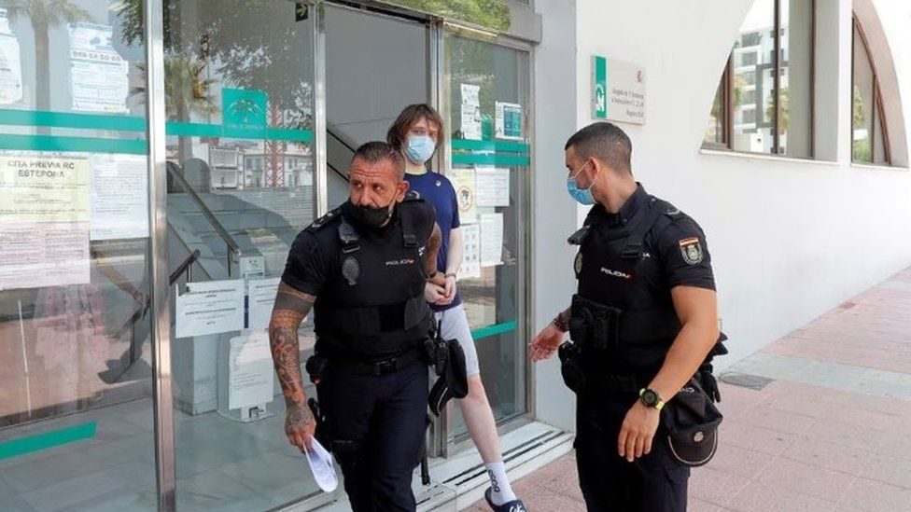IMAGE SOURCE,REUTERS

Image caption,

Joseph O'Connor was arrested in Spain in 2021 and extradited to the US in April

A British man who hacked high profile Twitter accounts as part of a Bitcoin scam has been jailed in the US.

Joseph O'Connor, from Liverpool, hijacked more than 130 accounts in July 2020, including those of Barack Obama, Joe Biden and Elon Musk.

The 24-year-old pleaded guilty to hacking charges last month.

On Friday, he was sentenced to five years for cyber crimes, according to the United States Attorney's Office in the southern district of New York.

The hacking was part of a major Bitcoin scam that generated tweets asking followers to send Bitcoin to an account, promising to double their money.

As a result of the fraud, an estimated 350 million Twitter users viewed suspicious tweets from official accounts of some of the platform's biggest users, including Apple, Uber, Kanye West and Bill Gates.

Thousands were duped into believing that a crypto giveaway was real.

[Twitter hack: What went wrong?](https://www.bbc.co.uk/news/technology-53428304)

O'Connor, who went by the alias PlugwalkJoe, was extradited from Spain to the US in April and last month pleaded guilty to hacking charges that carried a total maximum sentence of more than 70 years.

Three other men have been charged over the scam, with US teenager [Graham Clark pleading guilty](https://www.bbc.co.uk/news/technology-56429204.amp) to his part in the deception in 2021.

The hackers telephoned a small number of Twitter employees with a believable tale to convince them to hand over their internal login details - which eventually granted them access to Twitter's administrative tools.

They managed to use [social engineering tricks](https://www.justice.gov/usao-sdny/pr/uk-citizen-sentenced-five-years-prison-cybercrime-offenses) - more akin to conmen than high-level cyber-criminals - to get access to the powerful internal control panel at the site.

In a statement, US Assistant Attorney-General Kenneth Polite Jr described O'Connor's actions as "flagrant and malicious", saying he had "harassed, threatened and extorted his victims, causing substantial emotional harm".

The US justice department also said O'Connor admitted other hacking crimes including gaining access to a high-profile TikTok account and stalking a minor.

He was also ordered to pay almost $800,000 in forfeiture, the US justice department said.

**#5**

**Former Apple car engineer pleads guilty to trade secret theft**

[*https://www.aljazeera.com/economy/2022/8/23/former-apple-car-engineer-pleads-guilty-to-trade-secret-theft*](https://www.aljazeera.com/economy/2022/8/23/former-apple-car-engineer-pleads-guilty-to-trade-secret-theft)

*Prosecutors alleged worker downloaded plans for Apple’s self-driving program before booking last-minute flight to China.*



A former Apple engineer has pleaded guilty to stealing trade secrets from the iPhone maker's nascent self-driving car program [File: Dado Ruvic/Reuters]

Published On 23 Aug 202223 Aug 2022

A former Apple engineer has pleaded guilty to trade secret theft — one of two people accused of stealing trade secrets from the iPhone maker’s nascent self-driving car program.

United States federal prosecutors have alleged that Xiaolang Zhang downloaded the plan for a circuit board for Apple’s self-driving system after disclosing his intentions to work for a Chinese self-driving car startup and booking a last-minute flight to China.

He was arrested at the San Jose airport after he passed through a security checkpoint.

Zhang initially pleaded not guilty to the charges, but according to court documents on Monday, he had reached a plea deal with prosecutors and changed his plea to guilty. The plea deal is sealed and sentencing is set for November.

Zhang’s lawyer confirmed the plea agreement but declined further comment. Apple and the US Department of Justice did not immediately respond to a request for comment.

Jizhong Chen, the other former Apple engineer charged with trade secret theft, has pleaded not guilty. He has a court hearing set for August 29.

**#6**

**Saudi freed in Lebanon after kidnapping**

[*https://www.aljazeera.com/news/2023/5/30/saudi-freed-in-lebanon-after-kidnapping*](https://www.aljazeera.com/news/2023/5/30/saudi-freed-in-lebanon-after-kidnapping)

*Lebanese interior ministry says that nine people had been arrested in connection with Sunday’s kidnapping.*

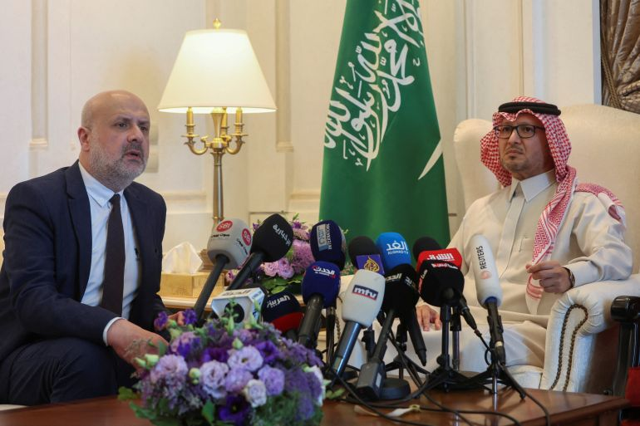

Saudi Ambassador to Lebanon Walid bin Abdullah Bukhari and Lebanon's caretaker Interior Minister Bassam Mawlawi attend a news conference at Saudi Arabia's embassy in Beirut, Lebanon [Mohamed Azakir/Reuters]

Published On 30 May 202330 May 2023

A Saudi national who had been kidnapped in Beirut on Sunday has been freed in a special operation by the Lebanese army near the Syrian border.

“An army intelligence patrol managed to free kidnapped Saudi national Mashari al-Mutairi during a special operation on the Syrian border and a number of those involved in the kidnapping were also arrested,” the Lebanese army said in a statement on Monday.

The Lebanese Interior Minister Bassam Mawlawi added at a news conference that nine people had been taken into custody over the kidnapping.

Unidentified assailants dressed as security personnel in a four-wheel drive vehicle on the Beirut seafront kidnapped the Saudi, who had been in a restaurant, according to a senior Lebanese security source.

The kidnappers had asked for a $400,000 ransom, Saudi local media reported, but Mawlawi said that it had not been paid.

Saudi Arabia asked its diplomatic staff in Lebanon to stay home after the incident.

Prime Minister Najib Mikati congratulated the army on the “great effort deployed to release him and arrest those involved in the kidnapping”.

Mawlawi also promised on Twitter that the kidnappers would be “punished harshly”.

Kidnappings have taken place in the past, with a Saudi abducted for ransom in July 2022, upon his arrival at Beirut airport.

Since 2021, Saudi citizens have had to obtain their government’s permission before travelling to Lebanon because of strained diplomatic ties between the two countries.

Lebanon has witnessed a rise in crime since 2019, when the country’s economic system crashed under the weight of state corruption and mismanagement by the ruling elites.

Saudi Arabia was once a major donor for Lebanon but relations worsened in recent years, partly as a result of the growing influence of the Iran-backed Hezbollah movement.

Saudi Arabia [returned its ambassador to Beirut in April 2022](https://www.aljazeera.com/news/2022/4/7/saudi-announces-return-of-ambassador-to-lebanon), after recalling him the previous October amid a diplomatic dispute that followed a Lebanese minister criticising the kingdom’s conduct in the war in Yemen.

**#7**

**Morocco Arrests Three Suspects for Armored Truck Robbery in Tangier**

<https://www.moroccoworldnews.com/2021/12/346032/morocco-arrests-three-suspects-for-armored-truck-robbery-in-tangier>

The incident made national headlines, with some describing it as a Hollywood-grade heist case.

* [**Safaa Kasraoui**](https://www.moroccoworldnews.com/author/kasraoui-safaa)
* **Dec. 15, 2021 4:47 p.m.**

[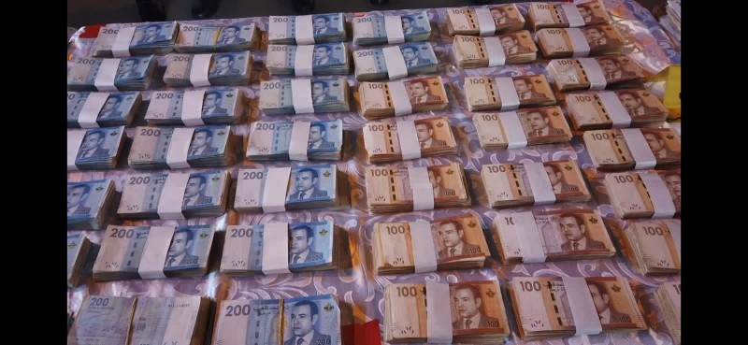](https://www.moroccoworldnews.com/2021/12/346032/morocco-arrests-three-suspects-for-armored-truck-robbery-in-tangier)

Morocco Arrests Three Suspects for Armored Truck Robbery in Tangier

On Wednesday, judicial police in Tangier arrested three suspects for their involvement in the robbery of considerable sums of money from an armored truck.

The suspects are aged between 28 and 32, and include one man who has a criminal record for theft, a statement from the General Directorate of National Security (DGSN) said today.

[DGSN](https://twitter.com/dgsn_maroc?lang=en)said the arrest operation took place in collaboration with the General Directorate of Territorial Surveillance (DGST).

The three suspects robbed an amount of MAD 1,600,000 ($172,762). The [heist](https://twitter.com/dgsn_maroc?lang=en)took place November 22 in Tangier. Investigations enabled the arrest of the brother of one of the main suspects. The brother, though not suspected in the robbery, is suspected of concealing an important part of the stolen money.

Searches enabled police to seize and recover an undisclosed sum of the money. Police also seized weapons, such as knives of different sizes, as well as large bags of wheat and a car used for criminal acts, [DGSN](https://www.moroccoworldnews.com/2021/12/346027/police-seize-1-1-tonnes-of-cannabis-in-tangier)said.

Police put all of the suspects into custody for further investigation to determine the circumstances of the case and to identify all criminal acts attributed to the defendants. The case made national headlines in November, with many describing it as a Hollywood-grade heist.

The masked suspects stole the money while bank security personnel were unloading the cash from the armored truck. Several similar cases took place, including one in Asfi, a port city in western Morocco, where police arrested a suspect for a robbery involving MAD 200 million.

**#8**

**World’s ‘most wanted people smuggler’ arrested in Sudan**

[*https://www.aljazeera.com/news/2023/1/5/uae-says-it-helped-arrest-worlds-most-wanted-people-smuggler*](https://www.aljazeera.com/news/2023/1/5/uae-says-it-helped-arrest-worlds-most-wanted-people-smuggler)

*UAE says it played key role in operation to detain Eritrean national Kidane Zekarias Habtemariam, wanted by Interpol.*

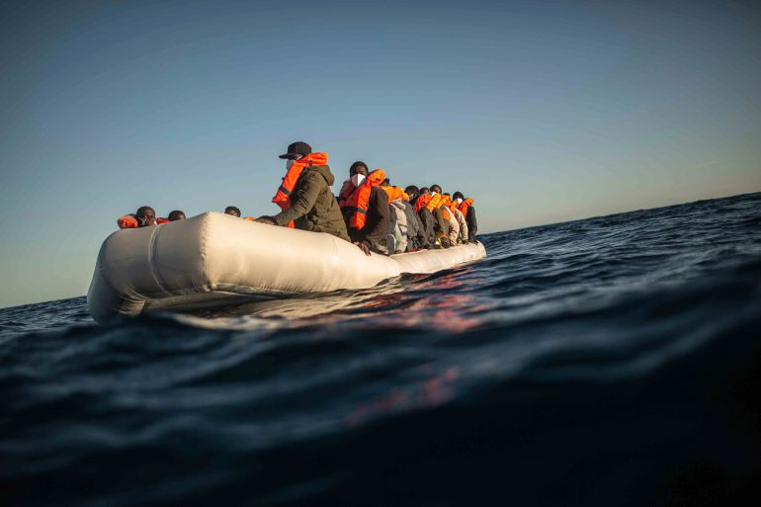

Habtemariam is believed to have smuggled and trafficked thousands of victims [Pablo Tosco/AP Photo]

Published On 5 Jan 20235 Jan 2023

An Eritrean fugitive accused of being “the world’s most wanted” people smuggler has been arrested in Sudan in coordination with UAE authorities, Interpol announced. Kidane Zekarias Habtemariam has been accused of being a smuggling kingpin, running a camp in Libya where hundreds of East African migrants seeking passage to Europe were allegedly kidnapped, raped and extorted.

Habtemariam, the subject of two Interpol red notices by Ethiopia and the Netherlands, was arrested on January 1 by Sudanese police in coordination with UAE authorities, UAE interior ministry official Saeed Abdullah al-Suwaidi told reporters on Thursday.

The Eritrean, on Interpol’s radar since 2019, earned a reputation for “particularly cruel and violent treatment of migrants”, Interpol [said](https://www.interpol.int/fr/Actualites-et-evenements/Actualites/2023/UAE-action-leads-to-arrest-of-people-smuggling-kingpin-in-Sudan). “We have now shut down one of the most important trafficking routes into Europe, which illegally moved thousands of migrants from Eritrea, Ethiopia, Somalia and Sudan, through Libya and into Europe,” al-Suwaidi said in a statement.

Habtemariam’s arrest followed a joint UAE and Interpol investigation, beginning last year, that tracked illicit financial transactions made by his brother, according to al-Suwaidi.

The Eritrean will now face trial in the UAE for money laundering, and authorities will review the possibility of his extradition after the case is closed in the UAE, Suwaidi added. Habtemariam was arrested in Ethiopia in 2020 but escaped custody after one year, and was later sentenced in absentia to life in prison.

He operated warehouses including in the Libyan town of Bani Walid and was known for extorting and torturing victims.

## ‘Horrific exploitation’

Habtemariam had worked with another infamous human smuggler, Tewelde Goitom, who was notorious for the number of [captive women he allegedly raped](https://www.aljazeera.com/news/2021/6/15/infamous-human-smuggler-sentenced-to-18-years-in-ethiopian-prison), according to victims Al Jazeera previously spoke to.

Habtemariam’s arrest will deal “a significant blow to a major smuggling route towards Europe and protect thousands more from being exploited at the hands of the crime group”, Interpol said.

Al-Suwaidi said the arrest was “just the beginning” of hunting down the rest of Habtemariam’s network, and the UAE is discussing with Interpol the possibility of launching another investigation into a major human trafficker. “The UAE will continue to deploy our full operational capabilities to protect vulnerable communities from this horrific exploitation,” he said.

Stephen Kavanagh, a director at Interpol, said Habtemariam was the “most wanted” criminal including in Ethiopia and the Netherlands. The arrest “is a testament to the Interpol network, and what can be achieved when countries work together”, Kavanagh said, thanking Ethiopia, the Netherlands, the UAE and Sudan for playing a “crucial role”.

The body said more arrests are expected as part of continuing investigations, and as coordination continues with several member states.

**#9**

**Zimbabwe police raid ‘back yard brewers’ as fake booze booms**

[*https://www.aljazeera.com/news/2023/4/24/zimbabwe-police-raid-back-yard-brewers-as-fake-booze-booms*](https://www.aljazeera.com/news/2023/4/24/zimbabwe-police-raid-back-yard-brewers-as-fake-booze-booms)

*Police are now frequently conducting raids to clamp down on home brewers across Zimbabwe.*

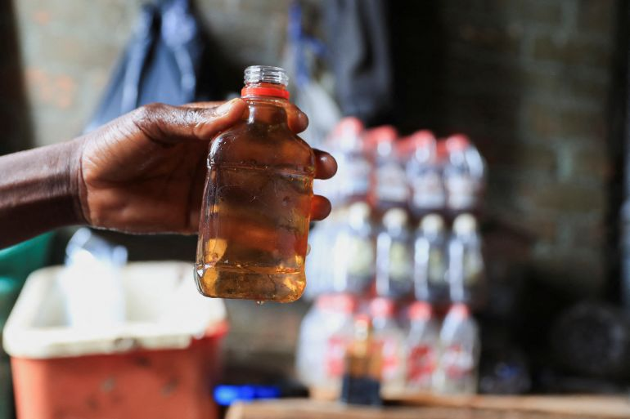

A person holds out a bottle at an informal brewing facility that makes fake whisky, brandy, vodka and other spirits, in Harare, Zimbabwe, March 23, 2023 [File: Philimon Bulawayo/Reuters]

Published On 24 Apr 202324 Apr 2023

Inside a grimy, poorly lit room in Mbare, one of Zimbabwe’s most populous townships, a 45-year-old man sits on a makeshift stool as he pours a brownish liquid into small bottles.

An alcoholic stench fills the room.

The Mbare resident is one of Zimbabwe’s “back yard brewers” who are making fake whiskies, brandy, vodka and other spirits to make ends meet amid fading hopes for economic prosperity.

“My life changed when I got into this business,” said the brewer, a former heavy machinery mechanic who did not want to be identified. “I left the [mechanics] industry because it was not paying much any more.”

Made from ethanol concentrate and diluted with large amounts of water and then mixed with a brown colouring mainly from baking products, the homemade brew has become popular among young people looking for cheap alcohol in bars in the townships.

A 250ml bottle of the brew, which imitates brands like Two Keys, Jack Daniels, and King Stallion Brandy retails at $0.50.

“We always check to see which label has more demand at any given time and make that,” said the brewer who ventured into business in 2011 in what he said now was a crowded market.

“We make the same [alcohol] but put different labels,” he added, chuckling.

Authorities have warned the practice is putting lives at risk because the home brewers have no mechanism to test the alcohol content accurately.

Police are now frequently conducting raids to clamp down on the brewing businesses.

“Wherever we find substances like illicit alcohol, we act,” police spokesperson Paul Nyathi told Reuters news agency, adding those arrested are charged with possession of dangerous drugs.

Since January, police have arrested 4,000 suspects countrywide, said Nyathi.

“The police raid us every day … business is not the same,” said the brewer. “It is now dangerous to display our products.”

Civil society groups say alcohol and drug abuse in Zimbabwe is on the rise amid economic hardships, with fake alcohol brands contributing to the scourge.

But there is no official data as to the number of people suffering from substance addiction in the country. Zimbabwe does not have publicly run substance abuse rehabilitation centres.

“The evidence on the ground points to a lot of illicit alcohol use,” said Knowledge Mupembe, a programme officer at Zimbabwe Civil Liberties and Drug Network. “We advocate for the establishment of public and affordable rehabilitation centres.”

**#10**

**Poachers’ paradise: Gulf hunts fuel Pakistan falcon trafficking**

[*https://www.aljazeera.com/news/2021/1/4/poachers-paradise-gulf-hunts-fuel-pakistan-falcon-trafficking*](https://www.aljazeera.com/news/2021/1/4/poachers-paradise-gulf-hunts-fuel-pakistan-falcon-trafficking)

*For years, Pakistan has stood at the nexus of the falcon trade, which though officially banned, is on the rise.*

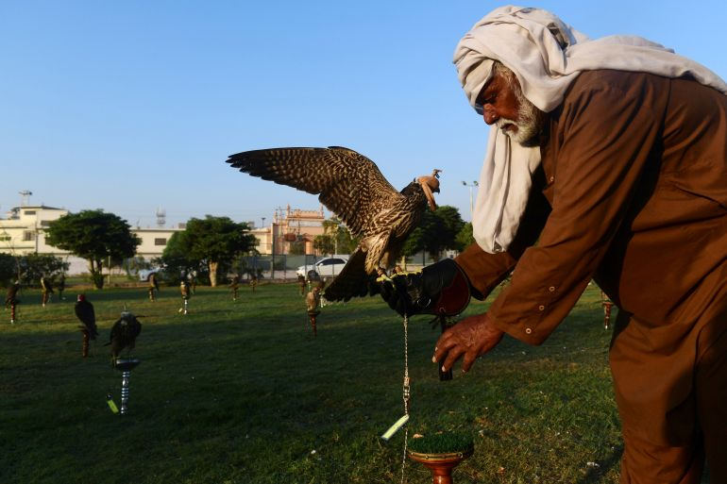

Wild birds are prized over those bred in captivity because they are believed to be better hunters, though there is no evidence to support those claims [Zain Zaman Janjua/AFP]

Published On 4 Jan 20214 Jan 2021

Since learning to capture birds as a teen, Muhammad Rafiq has amassed a small fortune in Pakistan trapping and trafficking falcons – including some endangered species – for wealthy Gulf Arabs.

A single falcon can fetch up to tens of thousands of dollars on the black market, which allowed Rafiq to renovate his family home.

“Every season, dealers come from Karachi and leave their contacts with us, and we call them back if we catch something,” said the 32-year-old, from a nearby coastal village.

He recently trapped a peregrine falcon during a one-week hunting mission.

“I desperately needed money,” he told AFP. “And God has listened to me.”

For years, Pakistan has stood at the nexus of the falcon trade, both as a source of the birds of prey, and then as a destination to hunt with them.

Falcon poaching is officially banned, but demand for the birds is rising, according to the World Wildlife Fund in Pakistan.

It estimates that up to 700 falcons were illegally smuggled out of the country last year alone, often by organised criminal networks.

Their destination is normally Gulf countries, where falconry is a treasured tradition.

Owners treat the birds “like their own children”, said Margit Muller, the director of Abu Dhabi’s falcon hospital, which treats 11,000 falcons annually, a number that has more than doubled in the past 10 years.

One conservationist told AFP an Arab falconer usually owns around five to six hundred birds, most of which will be captured in the wild in Pakistan or Mongolia.

Wild birds are prized over those bred in captivity because they are believed to be better hunters, though there is no evidence to support those claims.

## **Demand rising**

Every year, falcons escape the harsh Siberian winter and fly thousands of miles to warmer regions, including southern Pakistan.

During the migratory season, wildlife traffickers descend on villages along the Arabian Sea coastline, offering fishermen cash to briefly abandon their boats and try their hand at poaching.

“We pay them in advance, send food to their families and if they catch a bird that is precious, we happily give them motorbikes,” said one trafficker who spoke to AFP on the condition of anonymity.

A range of tactics can be employed – sticky liquids, net traps or, most commonly, using smaller birds as bait.

Poachers especially target the peregrine falcon, whose populations remain stable – but also the saker, which is endangered.

Bob Dalton, a veteran falcon conservationist, helped oversee the rehabilitation of dozens of falcons seized by Pakistani authorities in October, with officials estimating the cache to be worth well over $1m.

“The illegal trade is growing, there is more money being spent, more pursuit from the Gulf,” he told AFP.

“With the exception of one or two species, most falcon populations are in decline or on the point of being unstable.”

## **Regulating the market**

With continuing efforts to curtail rampant poaching failing, some officials in Pakistan have suggested regulating the falcon trapping market, inspired by a scheme involving another rare native species, the markhor – an elusive mountain goat with striking twisted horns found in Pakistan’s mountainous north.

Every year, foreigners shell out tens of thousands of dollars for a handful of trophy hunting permits, providing a financial incentive for communities to prevent poaching.

Naeem Ashraf Raja, the director of biodiversity at the ministry of climate change, said markhor numbers have rebounded as a result of this controversial conservation method.

With hunting parties set to descend on Pakistan again over the next few months, Kamran Khan Yousafzai, the president of Pakistan’s Falconry Association, said the country desperately needs to implement a sustainable wildlife programme.

“Arab falconers can’t resist coming to Pakistan. They have been coming to these hunting grounds for generations, and unless they face any real problems, they are not going to search for new destinations.”

**#11**

# **Court hands death sentence to Nayera Ashraf's accused murderer**

###### [**https://english.ahram.org.eg/News/471208.aspx**](https://english.ahram.org.eg/News/471208.aspx)

###### [**Ahram Online**](https://english.ahram.org.eg/WriterArticles/Ahram-Online/344/0.aspx)**, Wednesday 6 Jul 2022**

Mansoura Criminal Court has sentenced Mohamed Adel, the accused killer of Mansoura University student Nayera Ashraf to death on Wednesday.

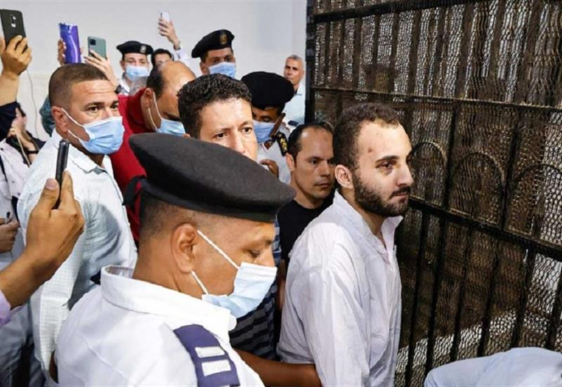

*Egyptian Mohamed Adel (C), the presumed murderer of university of Mansoura student Naira Ashraf, is surrounded by guards during as he is taken out of the defender s box, after his first trial session at the Mansoura courthouse, some 145km north of the capital Cairo, on June 26, 2022. AFP*

The court found Mohamed Adel, guilty of slaughtering and murdering his colleague Nayera Ashraf on the 20th of May,

The verdict is not final yet with the possiblty of an appeal.

During the trial, the prosecution presented to the court 25 eyewitnesses, including students and university guards who witnessed the stabbing of the 21-year-old student outside the gates of Mansoura University on 20 June.

Furthermore, the prosecution presented the testimonies of the victim's friends and colleagues, all of whom testified that the accused stalked and threatened the victim after rejecting his marriage proposal. The prosecution also stated that Nayera's family had previously filed several complaints at local police stations against the accused.

The state also presented to the court the detailed confessions of the accused as evidence, in addition to the victim's cell phone records and text messages that included death threats messages to Ashraf.

It also introduced into evidence footage of the incident from CCTV cameras around the university.

The court issued in its first session [on Sunday](https://english.ahram.org.eg/News/470626.aspx) a media gag order regarding the trial’s proceedings and sessions except for the sentence hearing.

The [crime](https://english.ahram.org.eg/NewsContent/1/1233/470455/Egypt/Courts--Law/Prosecution-refers-suspect-to-trial-in-Mansoura-st.aspx) gained widespread media attention and social commentary from various segments of Egyptian society, including women’s rights advocates and [controversial comments](https://english.ahram.org.eg/NewsContentP/1/470511/Egypt/Prominent-TV-Islamic-preacher-takes-leave-followin.aspx) from clerics.

**#12**

# **Egyptian court jails student in case that led to sex crimes debate**

[Reuters](https://www.reuters.com/authors/reuters/)

<https://www.reuters.com/world/middle-east/egyptian-court-jails-student-case-that-led-sex-crimes-debate-2021-04-11/>

April 11, 20216:34 PM GMT+2Updated 2 years ago

CAIRO, April 11 (Reuters) - An Egyptian court on Sunday sentenced a university student to eight years in jail for sex crimes, judicial sources said, in a case prompted by a social media campaign that opened up a rare public debate on sexual harassment.

Ahmed Bassam Zaki, in his early 20s, was referred to trial by public prosecutors in September on charges of the indecent assault and blackmail of at least three women, all under 18 at the time, between 2016 and 2020. He was detained in July.

Zaki, who was the target of a flurry of accusations on an Instagram account, showed no reaction as the sentence was read out at the criminal court in Cairo, the sources said.

He is not known to have addressed the accusations publicly and Reuters was not able to locate a lawyer representing him.

Zaki can appeal against the ruling before the court of cassation, Egypt's top civilian court, the sources said.

The case attracted widespread attention from media, religious figures and women's groups in a country where rights defenders say sexual harassment or abuse often goes unpunished.

Zaki was sentenced to three years in jail by another court in December for harassing two girls online. He has appealed against the ruling.

**#13**

# **Livestock theft is becoming more common in South Africa**

## **And more sophisticated**

<https://www.economist.com/middle-east-and-africa/2020/11/19/livestock-theft-is-becoming-more-common-in-south-africa>

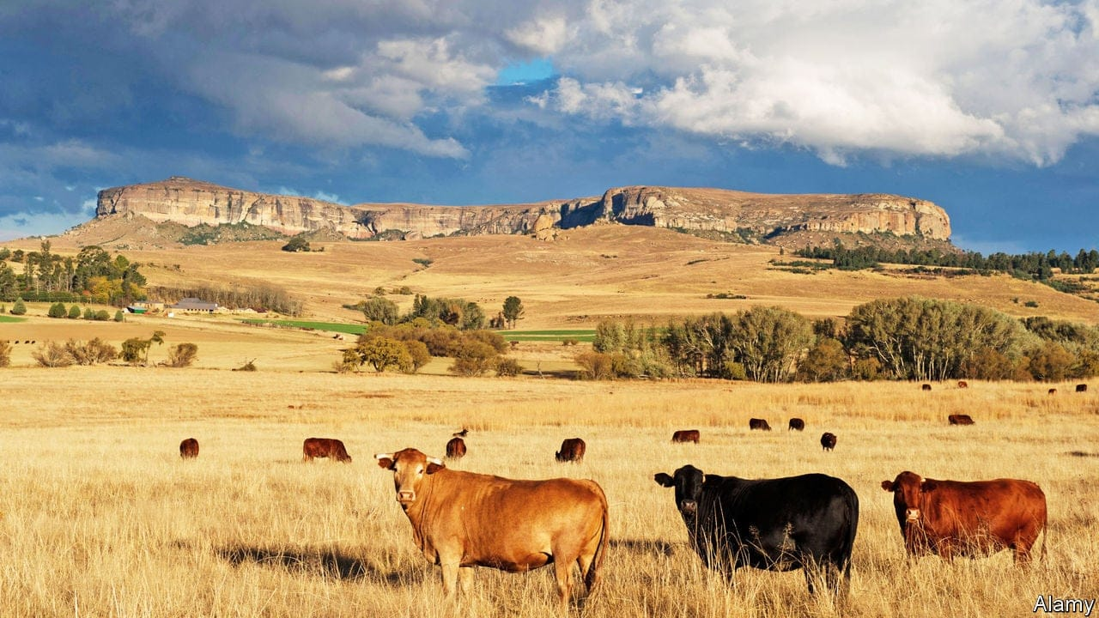

Nov 19th 2020 | BETHLEHEM

“Livestock theft has been around since Biblical times,” says Herkie Viljoen, a farmer on the outskirts of Bethlehem, a suitably named town in the Free State. But in recent years it has reached ungodly proportions. Standing next to a huge map of the province he points to small red circles with black dots that represent stolen animals. In some places it looks as if the farms are covered in poppy fields.

In South Africa 218,000 farm animals—cows, sheep or goats—were taken in the 12 months to March, up from 180,000 five years earlier. The total loss was worth about 900m rand ($60m) in each of the past two years, around twice as much as the annual black market value of poached rhino horn. Losses this year will probably be even higher, as the economic effects of the pandemic make it harder to earn a lawful living.

A few decades ago pilferage was “for the pot”. Today 87% of cases involve criminal syndicates, says Willie Clack of the University of South Africa. Gangs act differently in different places. In parts of the Free State and neighbouring KwaZulu Natal thieves often load cows onto lorries, then cross into Lesotho. Inside the mountain kingdom, which is encircled by South Africa, syndicates rebrand cattle before taking them back across the border, for sale at auction or to abattoirs. It is like laundering cars, but with cows instead of Porsches.

Livestock theft can be seen through a racial lens. The victims of the largest heists in the Free State are white Afrikaners who run big farms. Perhaps one-fifth of farm murders in the province—allegedly including the high-profile killing of Brendin Horner, a 21-year-old farm manager‚ on October 1st—are related to syndicates. Yet the victims in most cases of theft are black smallholders. As they own fewer animals, single incidents can ruin entire livelihoods.

Whites and blacks are both victims of a sclerotic criminal-justice system. There are dedicated Stock Theft Units within the police but they are siloed and poorly funded. A lack of arrests and prosecutions means there is “no deterrence”, argues Roy Jankielsohn, the leader of the opposition Democratic Alliance in the Free State. After the murder of Mr Horner, Bheki Cele, the national police minister, pledged that he would investigate livestock syndicates. “I’ve seen the stock-theft figures—it’s hell,” he said, adding that if police were found taking bribes they would have to swap their blue uniforms for orange jumpsuits.

In the meantime farmers are protecting themselves. For as is often the case in South Africa, people who can afford to do so are finding private solutions to public-sector problems. Mr Viljoen’s “command centre”, which is funded by 450 local farmers, uses 65,000 cctv cameras to look for rustlers. Farmers are also deploying drones and gps-tagging to find purloined stock.

Yet such measures can only go so far. After visiting the command centre your correspondent heads to the Caledon river, which marks the border with Lesotho, passing two empty chairs where soldiers are meant to keep watch. Donkeys and cows quench their thirst while children joyfully splash back and forth from one country to another. “You see!” a young boy cries out. “There’s no border!”

**#14**

# Algeria: ex-security chief sent to prison for attempted election fraud

<https://www.middleeastmonitor.com/20230605-algeria-ex-security-chief-sent-to-prison-for-attempted-election-fraud/>

June 5, 2023 at 8:42 am | Published in: [Africa](https://www.middleeastmonitor.com/category/region/africa-2/), [Algeria](https://www.middleeastmonitor.com/category/region/africa-2/algeria/), [News](https://www.middleeastmonitor.com/category/news-2/)

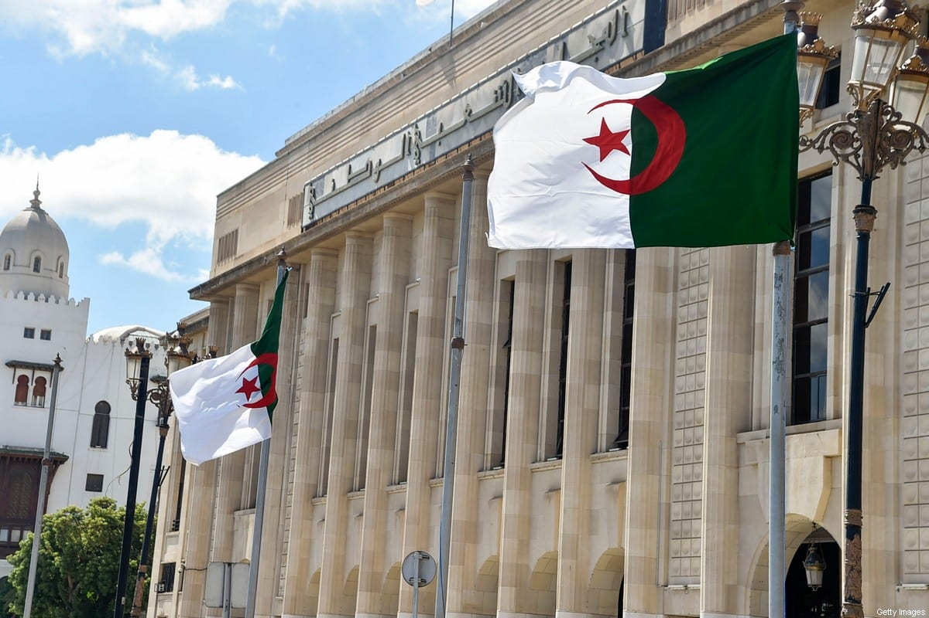

June 5, 2023 at 8:42 am

A court in Algeria has confirmed the sentence of a former director of Internal Security to 16 years in prison, Al-Quds Al-Arabi has reported. Wassini Bouazza was charged with attempting to fix the result of the 2019 presidential election in favour of the then Minister of Culture, Azzedine Mihoubi.

According to the Francophone newspaper Al-Watan, Bouazza was on trial alongside five officers under his command. The trial concluded on Thursday evening with the confirmation of his conviction. Some of the other defendants had their sentences reduced by the military appeals court. The Supreme Court overturned the previous rulings against Bouazza by the appeal court in Blida in September 2021.

Former brigadier general Bouazza was stripped of his rank after facing charges including abuse of authority, violation of military orders and obstruction of justice, as well as "interference" in the presidential election, which was won by current President Abdelmadjid Tebboune. Bouazza awaits two further cases against him, one of which involves a non-commissioned officer, Kermit Benouira, the private secretary of the late Chief of Staff Ahmed Gaid Salah, who is accused of disclosing military secrets.

Al-Watan quoted the defendants during the trial as saying that they merely followed the orders of their immediate superior. According to some lawyers, though, Bouazza claimed that it was Salah who ordered him to support Mihoubi in the election.

Bouazza was dismissed as head of Internal Security in Algeria in April 2020, months after Tebboune took office. He was replaced by Brigadier General Abdelghani Rachdi.

# **#15**

# Pennsylvania man convicted of torturing victim for 39 days, exporting weapons parts to Iraq

[**https://www.cbsnews.com/news/ross-roggio-pennsylvania-convicted-torturing-victim-illegal-weapons-parts-iraq/**](https://www.cbsnews.com/news/ross-roggio-pennsylvania-convicted-torturing-victim-illegal-weapons-parts-iraq/)

**BY KERRY BREEN**

**MAY 23, 2023 / 11:05 AM / CBS NEWS**

A Pennsylvania man was convicted of multiple crimes, including torture, in connection with the operation of an illegal weapons manufacturing plant in Iraq.

The 54-year-old man, [identified by federal authorities](https://www.justice.gov/opa/pr/man-convicted-torture-and-exporting-weapons-parts-and-related-services-iraq) as Ross Roggio of Stroudsburg, Pennsylvania, was convicted by a federal jury on May 19. The Department of Justice announced the outcome of the trial in a news release shared on Monday. The crimes took place in the Kurdistan region of Iraq.

Roggio was developing a weapons factory in the region, where he provided training to foreign citizens involved in the operation, assembly and manufacturing of the M4 automatic rifle. He also illegally exported weapons parts that were under restriction from the U.S. State and Commerce Departments.

According to court documents and trial evidence, Roggio tortured an Estonian citizen who worked at the factory for over a month in 2015. The victim, who was not identified, was abducted and detained at a Kurdish military compound, where Roggio suffocated and threatened him. Roggio also directed Kurdish soldiers at the compound to beat and "otherwise physically and mentally abuse" the victim for 39 days.

The victim eventually came forward, which officials said led to Roggio's conviction on multiple counts.

"Roggio brutally tortured another human being to prevent interference with his illegal activities," said Assistant Attorney General Kenneth A. Polite, Jr. of the Justice Department's Criminal Division in a news release. "Thanks to the courage of the victim and other witnesses, the hard work of U.S. law enforcement, and the assistance of Estonian authorities, he will now be held accountable for his cruelty."

Roggio was convicted of torture, conspiracy to commit torture, conspiring to commit an offense against the United States, exporting weapons parts and services to Iraq without the approval of the Department of State, exporting weapons tools to Iraq without the approval of the Department of Commerce, smuggling goods, wire fraud, and money laundering. He faces life in prison and will be sentenced on Aug. 23.